**Beginners guide to**

**Scratch**

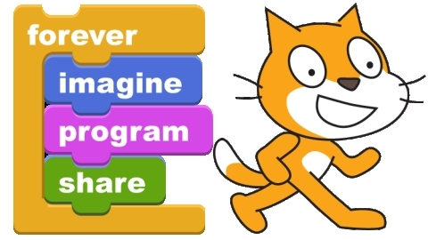

**Name ___________________________**

**Class ___________________________**

**By Andrew Mulholland and UnknownScratch** is a programming environment that enables you to make your own games, animations, stories, music and art.  To get an idea of the sorts of projects you can make with Scratch, you should look at the official Scratch website.  There you will find a gallery of projects submitted by people from all around the world.

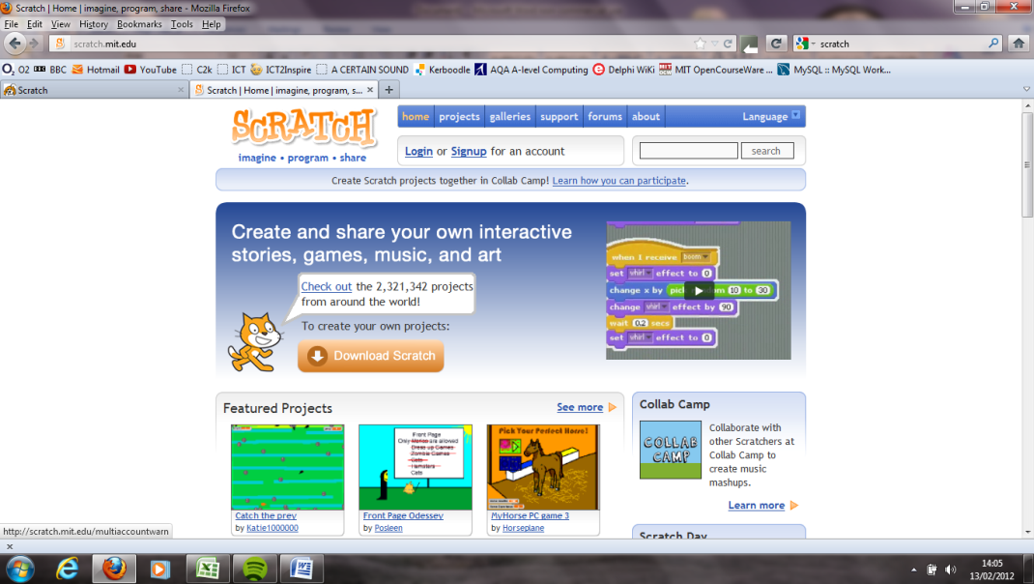

Once you get started using Scratch yourself, you should create an account on the Scratch website so that you can share your own creations.

Google SCRATCH and spend a few minutes looking at some of the Scratch programs that have been uploaded by others!

Getting started

* Open up a new Scratch Project.
* In the **SCRIPTS** area, click on the **MOTION** category. Beneath, lots of MOTION **SCRIPTS** will appear. A motion script is simply a command that is issued to a **SPRITE**. A sprite is a character on your Screen or **STAGE**.

Fill in the boxes below using the following keywords: SCRIPTS SPRITE STAGE

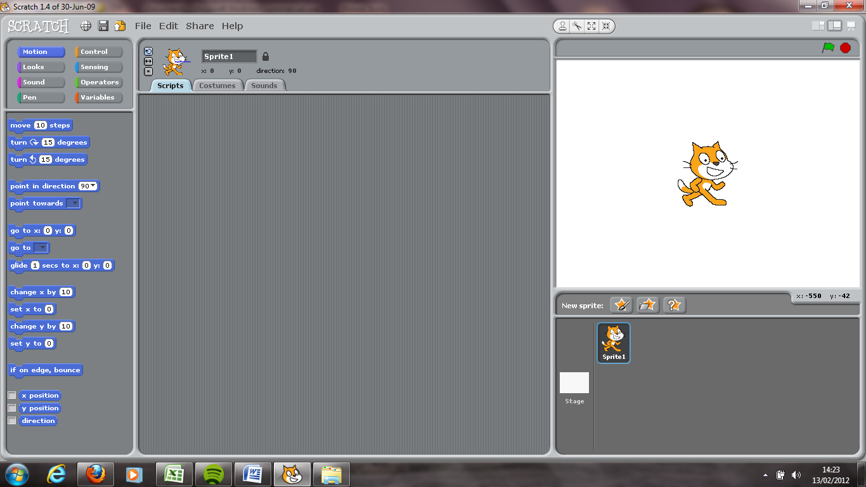

* Drag a **Move** block onto the scripts area.

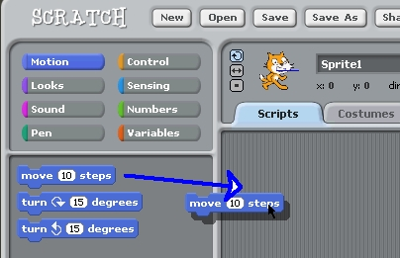

* Double click the block to make the cat move.

Making sound

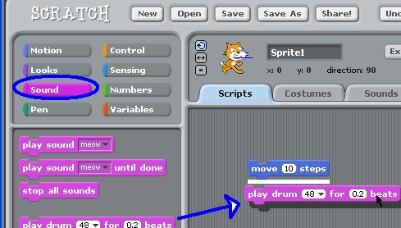

* Click on the **Sound** Scripts category.
* Drag out a **Play Drum** script block and sit it under the Move block until it clicks into place.

**Hint**: When you see the white line, you can let go.

* Now double click on the blocks to see what happens.
* Add in two more blocks as shown here.

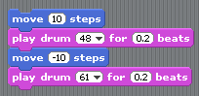

* Change the second move block to say -10 steps (Click on the white area and type it in)
* Click on the white area of the drum to change the instrument. Now click anywhere on the block to test it.

Right…here’s the important bit!

If we want the sprite to continue doing this forever, we need to add in a special Script block.

*Repeat this forever!*

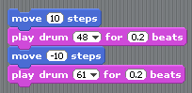

* From the Control script library, drag in a Forever block and drop it **below** the other blocks.

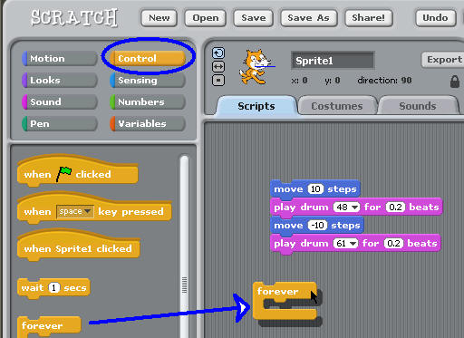

* Pick up your first stack of blocks by clicking on the top block.
* Drag it into the mouth of the forever block.

(*continued on next page*)

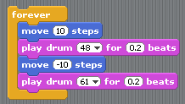

Double click the block and your program will run forever!



Click the red stop button to stop it!



* Save this Scratch project as **Cat Loop**.

*(Teacher show video ‘Consolidation Exercise 1’)*

For this exercise, you will need to look for script blocks not introduce so far. Just look in the following script block categories (MOTION, CONTROL & SOUND)

* Create a new Scratch Project called Consolidation Exercise 1
* Using the Cat Sprite (it’s called Sprite 1), create a program that does the following:
  1. Cat Moves 20 Steps
  2. Then Plays a sound ‘Meow’
  3. The sprite should immediately say ‘Meow!’ for 0.5 seconds
  4. There should be a 1.5 second wait
  5. ALL of these steps should happen in the sequence outlined above…and forever!

Save this project as **Consolidation Exercise 1**.

**Consolidation Exercise 1**

By the way…

…you can experiment and play around with different sprites. If you get bored of Cat sprite, you can select another from a library or paint your own. Just click here!

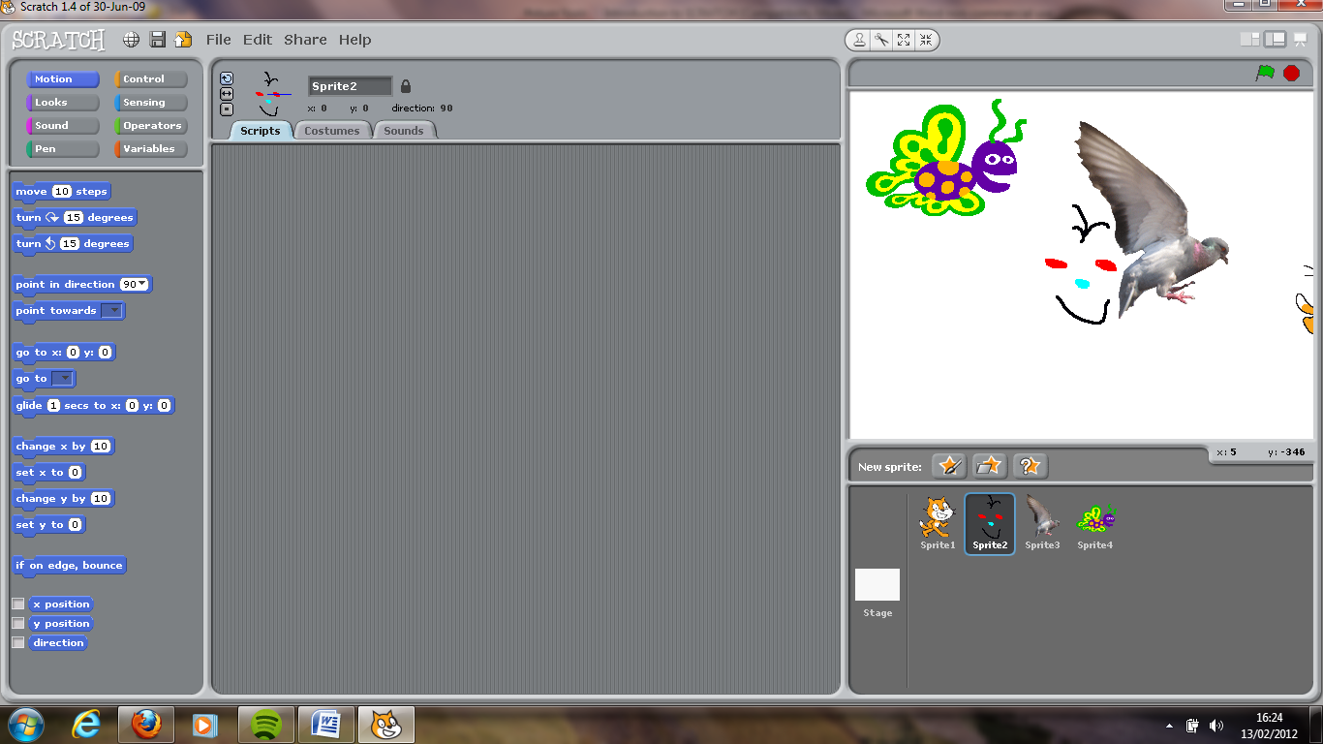

More motion stuff…

Ok…so you know how to move the sprite linearly (that is...in a straight line). Let’s try something different. Build the following script sequence.

* Double-click the script block and move your cursor repeatedly around the stage.

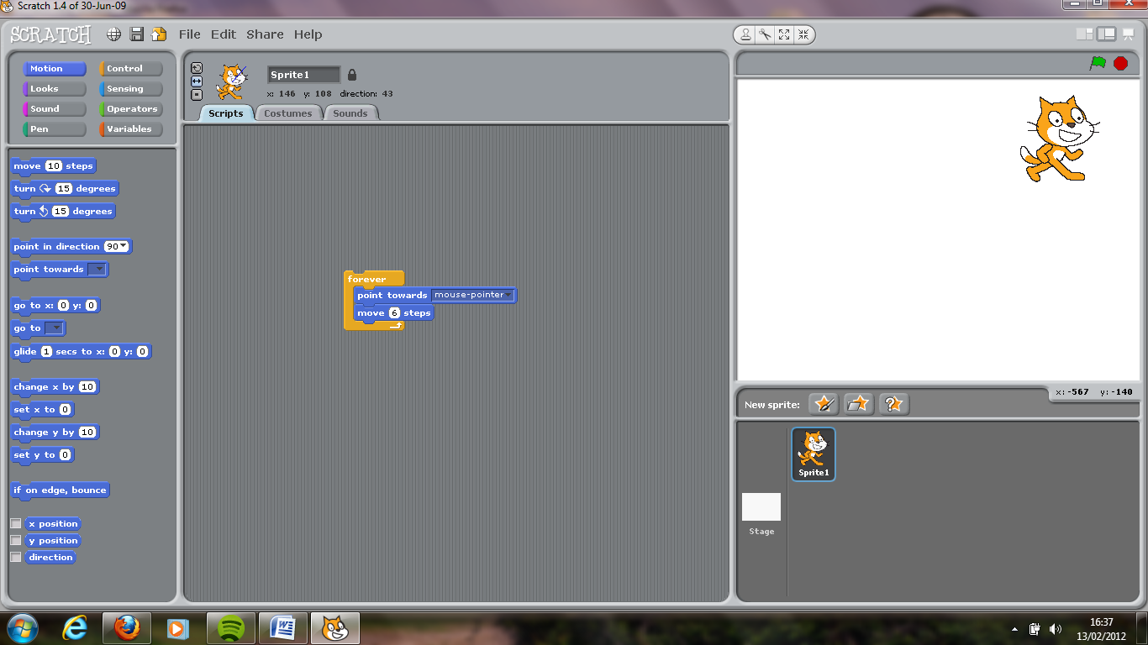

* Click STOP when you’re finished playing around!

find in ***Motion*** blocks

Adding sprites…

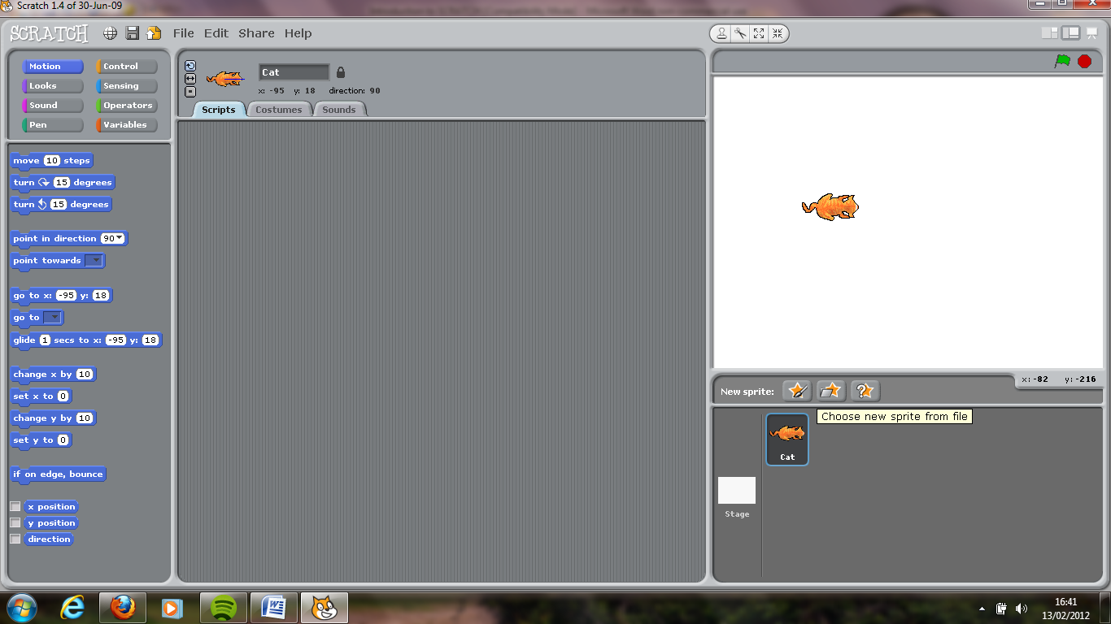

* Delete the first sprite (Sprite 1) by going to the sprites panel and deleting it from there.



* This time, choose a new sprite from file and find the Cat sprite. It should look like this.
* Add in the script, as above, **for the cat sprite**.
* Add in another new sprite. This time choose Paint New Sprite. Draw a mouse, from bird’s eye view…or something like this…

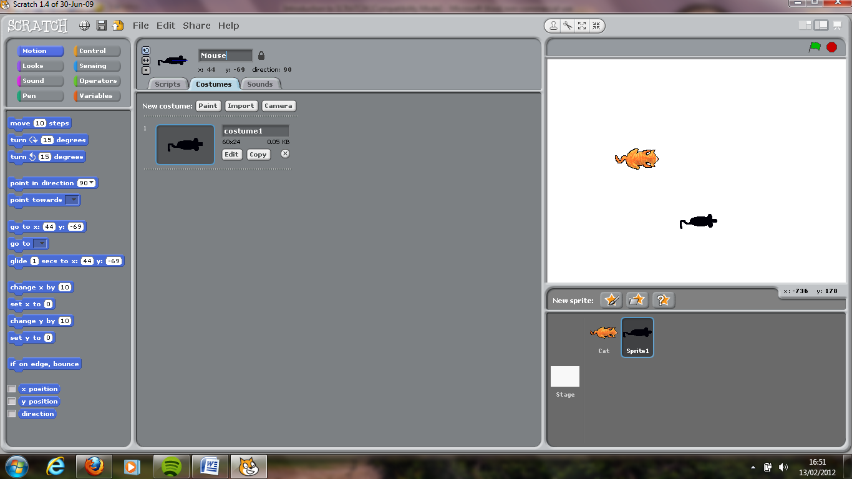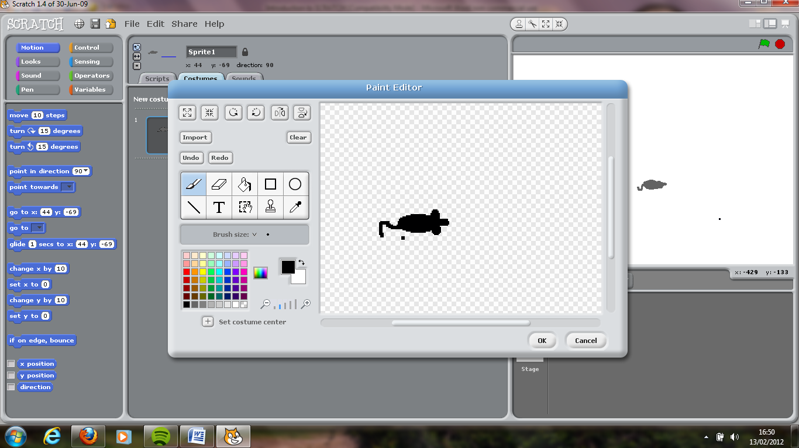

* Call this sprite ‘Mouse’.

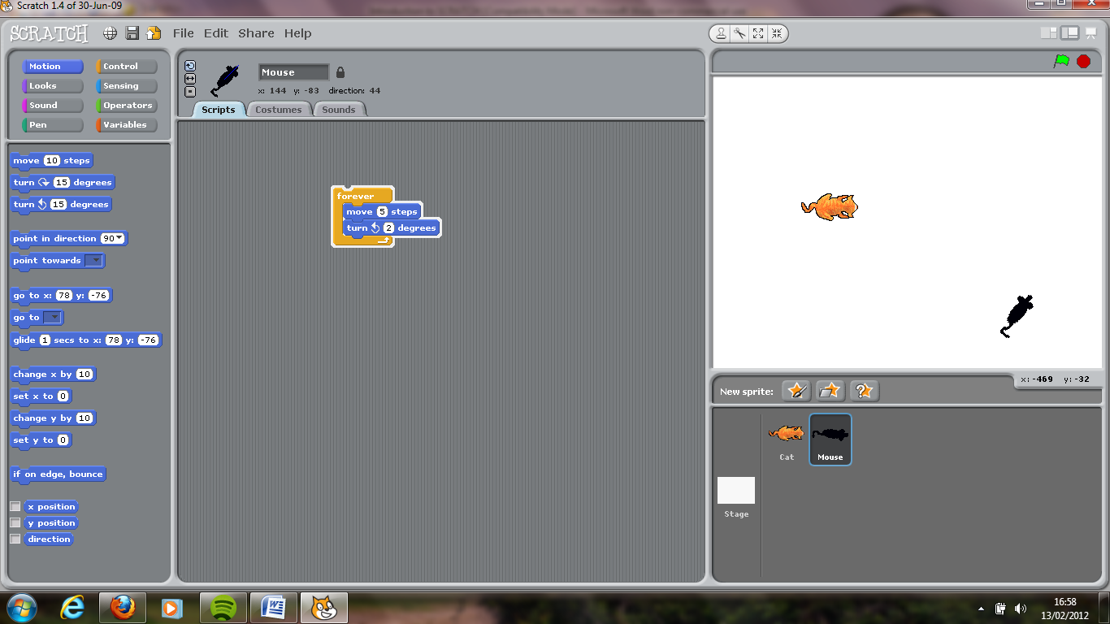

* Add the following script to the Mouse Sprite.
* Now, go back to the Cat Sprite and click it.

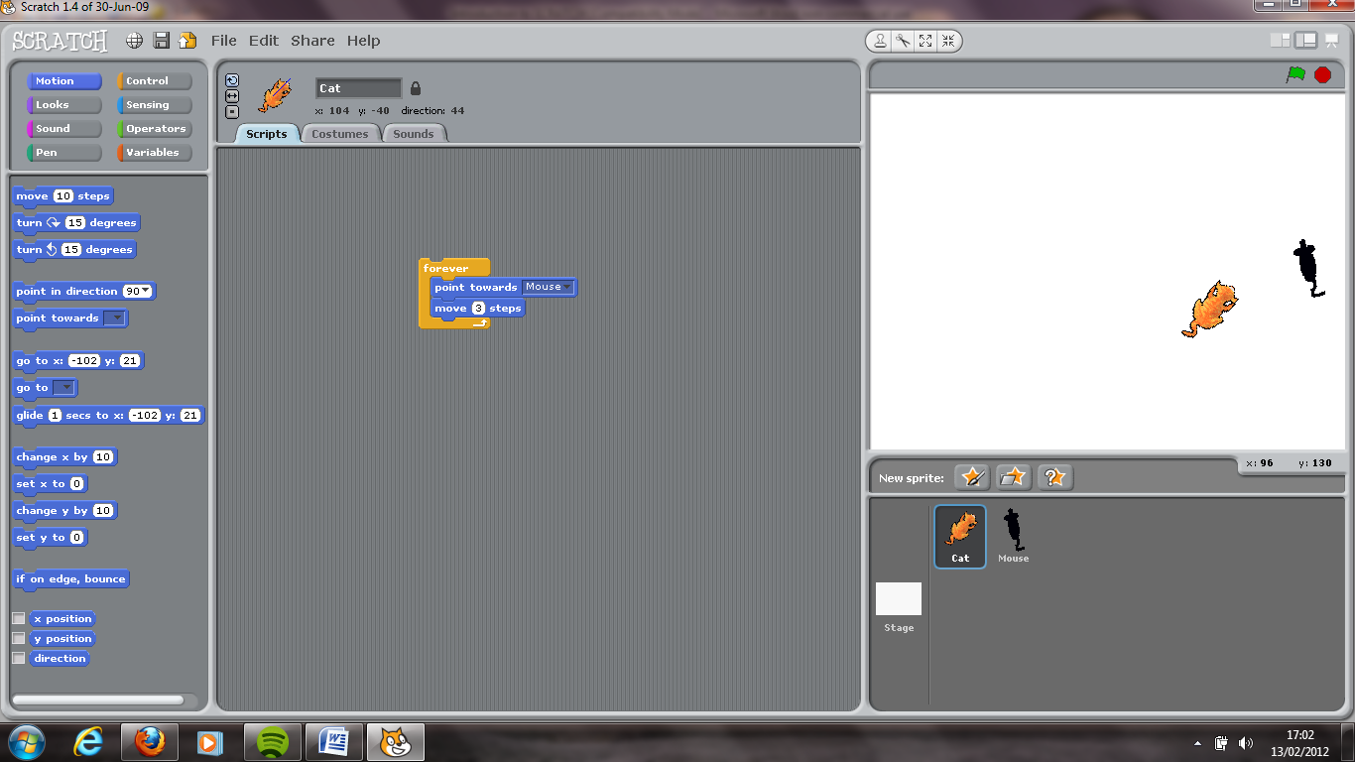

* Edit the script block for the cat to the following:
* Double-click the script blocks for both sprites…and enjoy the show.

Ok…Let’s make our little animation a wee bit more advanced.

What I’d like to happen is that the Cat chases the Mouse **UNTIL** it touches it. **THEN** it says ‘*Hmmm…Dinner*!’.

Here is what the Cat’s script block might look like:

***REPEAT UNTIL***

Cat touches Mouse

Point towards Mouse

Move **5** steps

Say ‘Hmm…dinner’ for 2 seconds.

Notice that we don’t use the **FOREVER** block. This is because we don’t want our scripts looping forever.

**REPEAT** **UNTIL** is a very useful block. Here is how we shall use it:

Look for ***<Touching >*** block in Sensing category. Choose ‘touching mouse’.

Look for ***REPEAT UNTIL*** block in Control category.

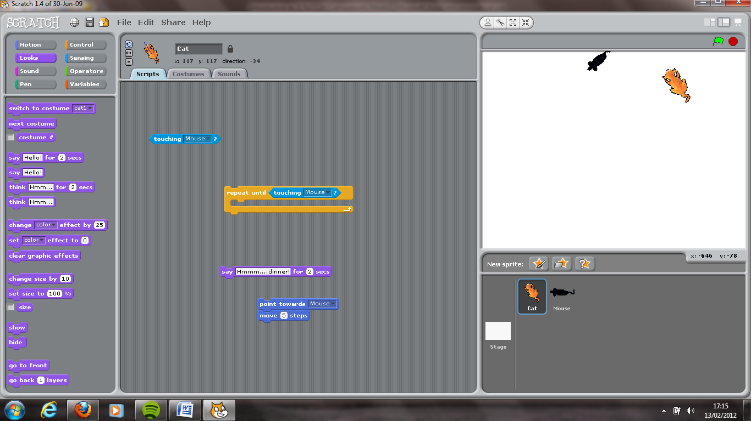

Look for ***<Touching >*** block in Sensing category. Choose ‘touching mouse’.

All the script blocks you want to repeat go in here.

Any scripts you want to run AFTER the repeat loop has FINISHED, place them here.

Try building this script block in Scratch:

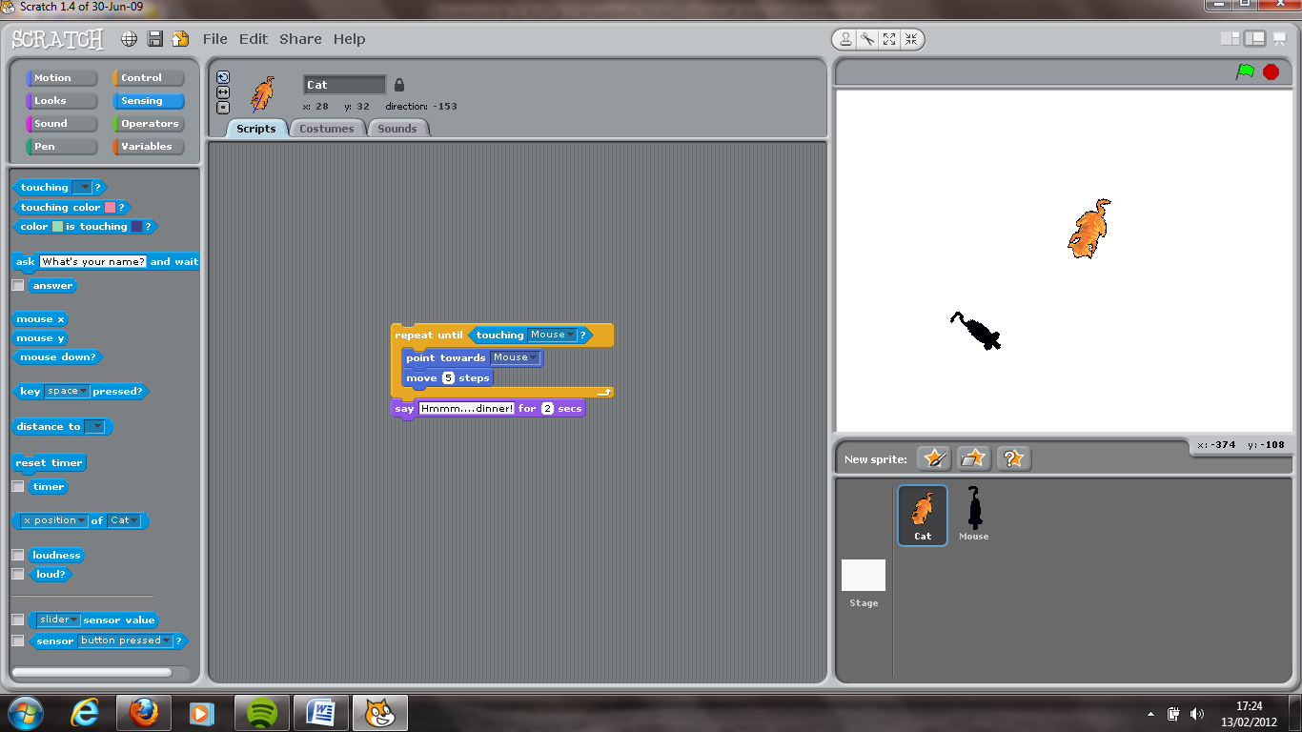

Double click the script block and watch the show.

LOOPING…& LOOPING…& LOOPING (…err I feel sick now)

Not quite there yet! The cat stops and that’s it. What if we want the cat to wait and then continue searching for the mouse again …and again…and again?

Well that’s easy…you keep looping it!

Point towards Mouse

Say ‘Hmm…dinner’ for 2 seconds.

***REPEAT UNTIL***

Cat touches Mouse

Move **5** steps

***FOREVER !***

What we have here is a lovely little thing called a **Nested Loop**! It is simply where you have one loop inside another! (PS: They will really impress your teacher!)

Here is mine:

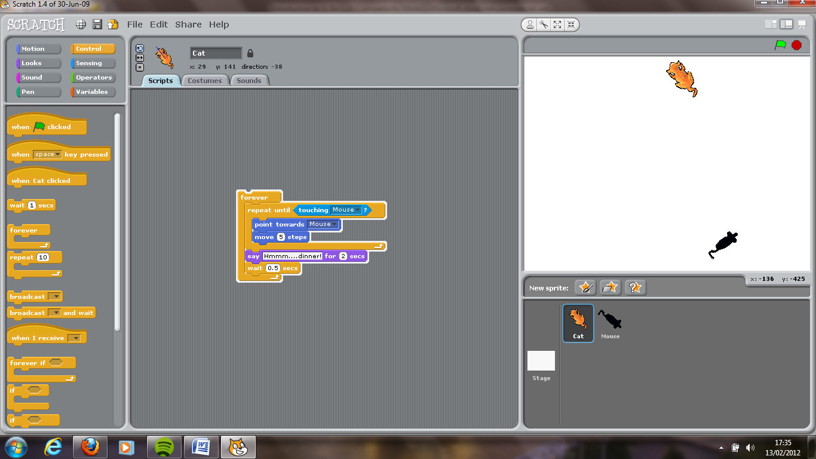

Save the Scratch project as **Cat and Mouse**

Note I inserted a **WAIT** block here. I think it helps.

*(Teacher show video ‘Consolidation Exercise 2’)*

***The Heist!***

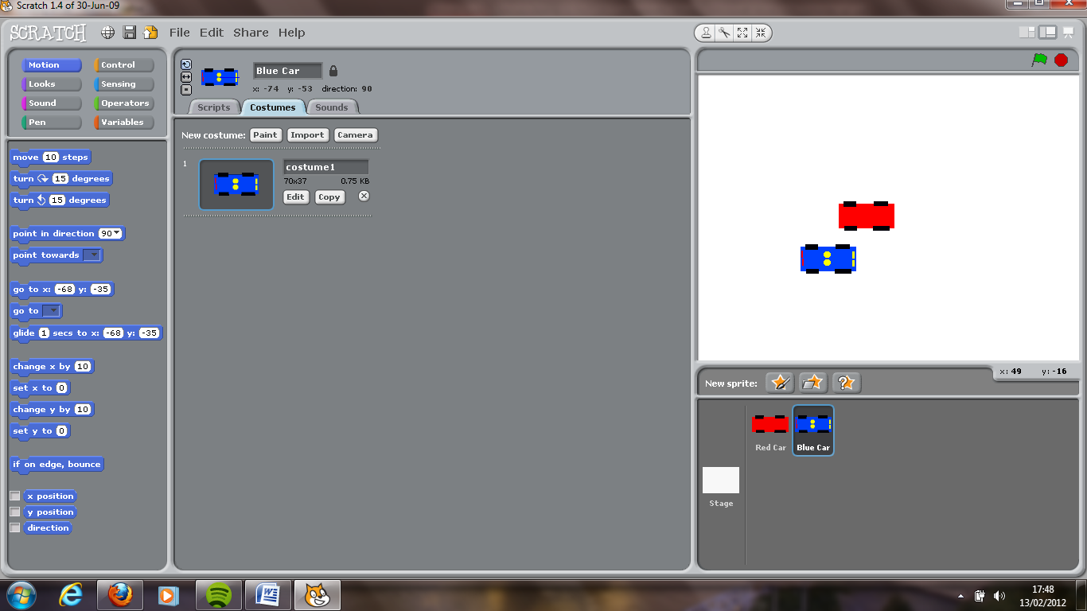

* Create a new Scratch Project called Consolidation Exercise 2
* Create two new sprites of your own. A blue car and a red car. The blue car is supposed to be a police car. Try your best to make it look like one. Here’s mine:
* Your program must do the following:
  1. The red car must continually move around screen UNTIL the blue police car catches it (i.e. touches it)

Move ‘x’ steps

If on edge, bounce

You should include the following blocks for your red car:

* 1. The police car must continually move around the screen FOLLOWING the red car UNTIL it catches it (i.e. touches it)
  2. Once the red car is caught, the police car must say ‘Gotcha! Hold’em up!’ for 1 sec.
  3. The red car will immediately move 10 steps if it has been caught.
  4. Then the entire sequence is repeated again and again…forever & ever…& ever…

**Consolidation Exercise 2**

***Optional Extension*** (try this if you can!)

Give the police car a repeating siren sound during play (runtime).

USER CONTROL

We could now introduce user interactivity at **RUN TIME** (i.e. that’s when a program is running!). The user can use any key on their keyboard to control a sprite’s movement! To try this, we will use the project file ‘Consolidation Exercise 2’.

* Open *Consolidation Exercise 2*.
* Once open, save the project as a new file name ‘*Control Sprite Movement’*.
* Click on the red car sprite. Remove all associated script blocks.

We want the red car to behave in the follow way…

When Up arrow key is pressed

Point Sprite upwards

Scratch it now…

Move sprite 5 steps

You will find this script block in the Control category

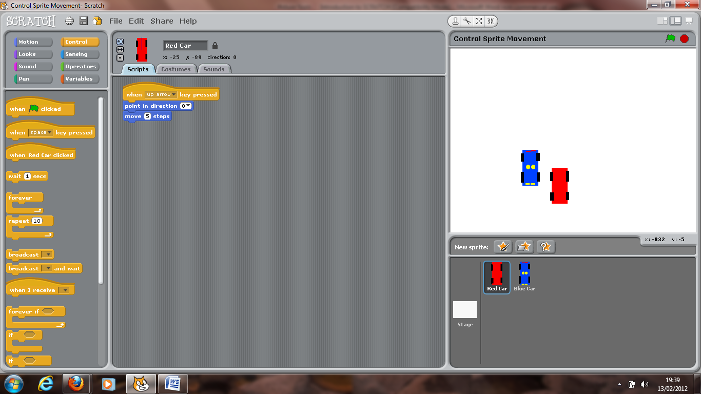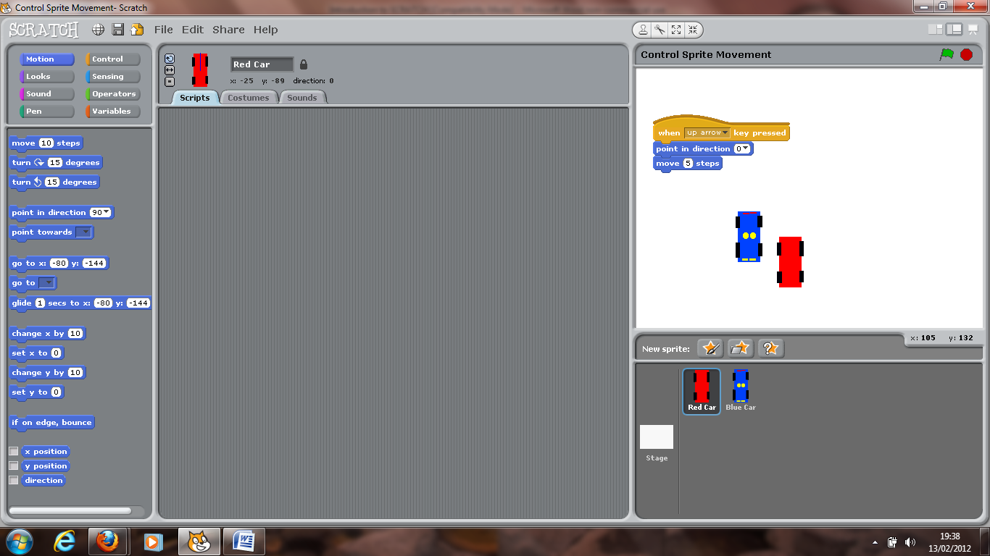

This will control the sprite’s *northbound* movements.

You need to repeat for the following directions:

*Eastbound*, *Westbound* and *Southbound*. Here’s how:

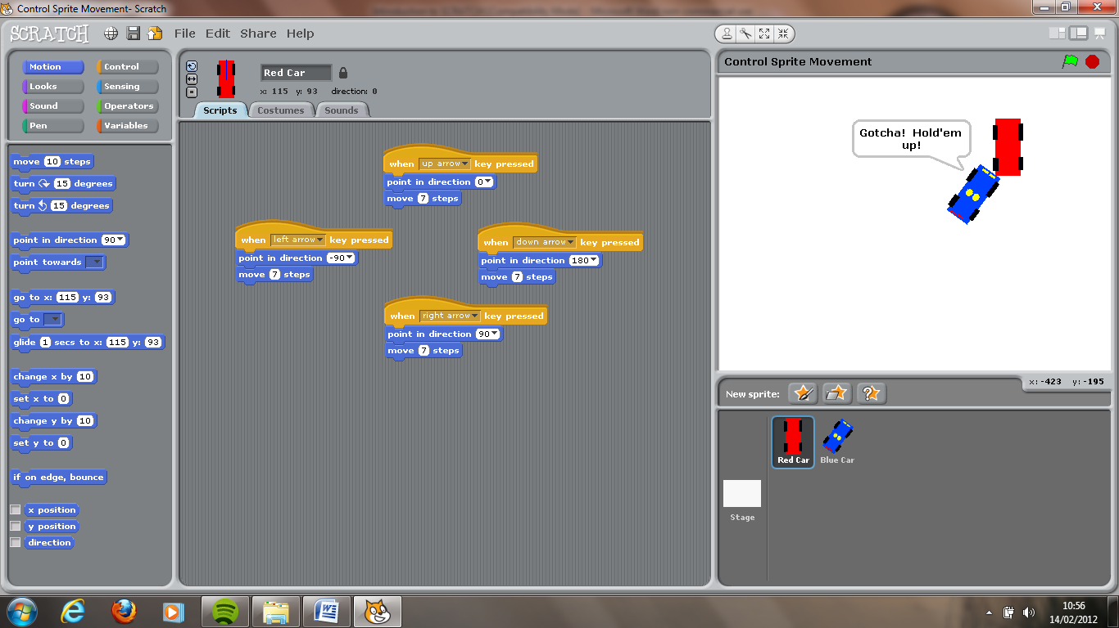

Wait! Don’t run it just yet.

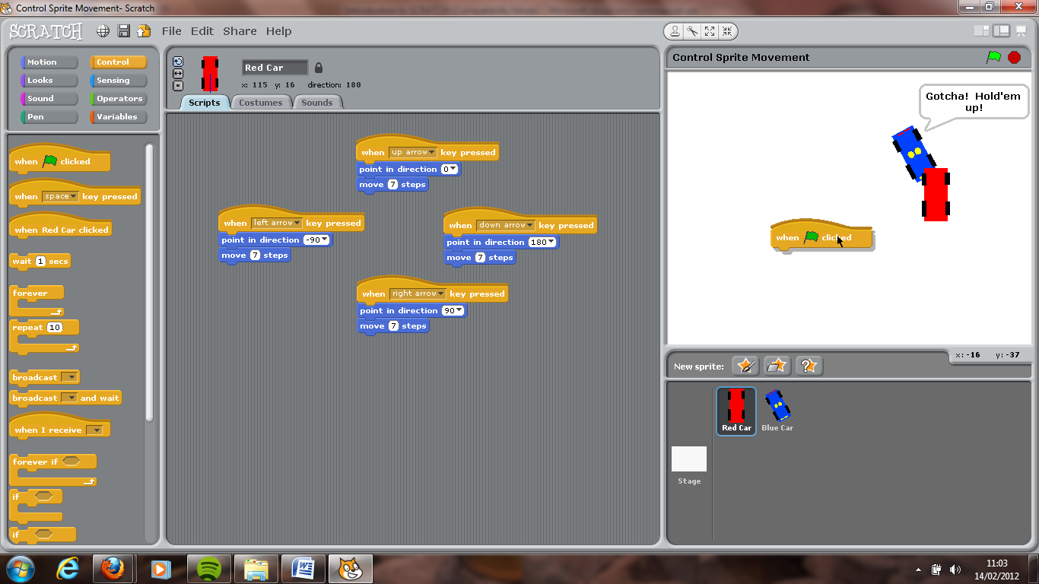

The GREEN FLAG

Look in the Control category for the green flag block.

This little block is **very useful**.

Instead of double-clicking a script block each time you want it to run, you can click on the green flag at the top-right of your screen.



**Any script block beginning with a green flag will automatically run!**

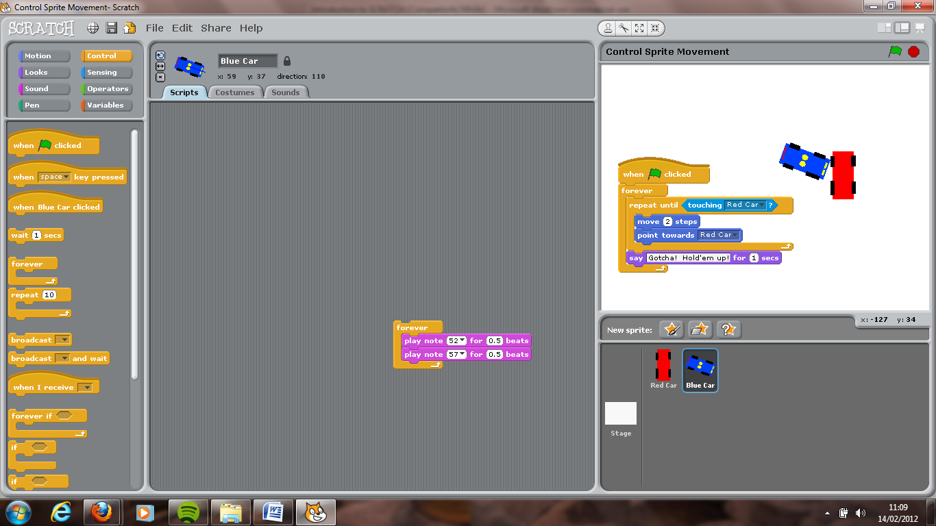

Now…Scratch it!...and click **Save**.

If you want to control the red getaway car with your mouse instead of the cursor keys…which I recommend you do…try this.

* Close the current Scratch Project.
* Open up Consolidation Exercise 2 again.
* Click on your red car sprite.
* Add the green flag block (called a ‘hat’) to the top of the existing sprite block so that it runs whenever the green flag is clicked by user.

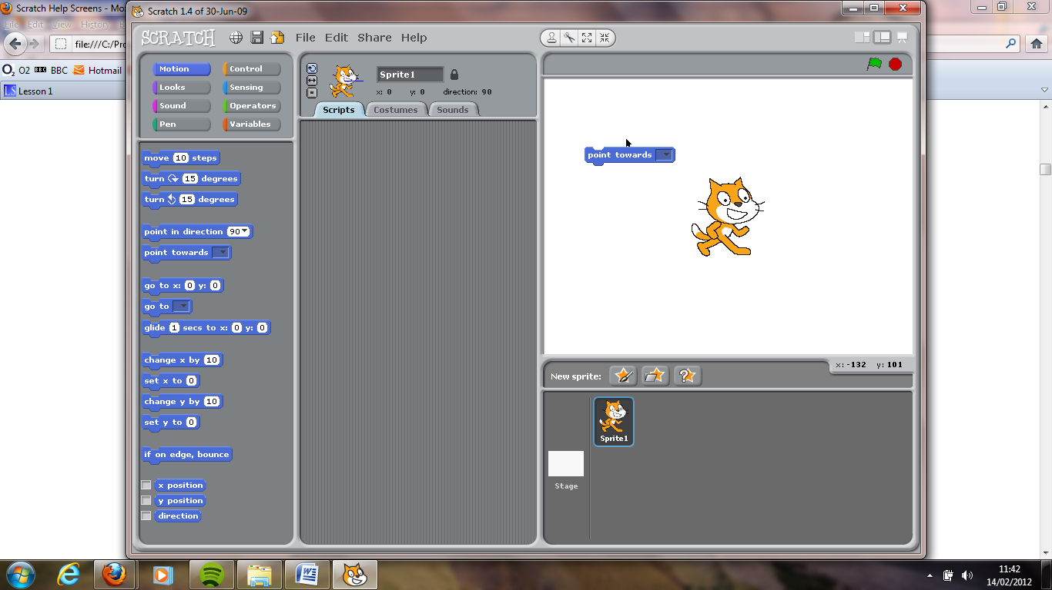

* Look in the Motion category for the following block:
* Change it so it says

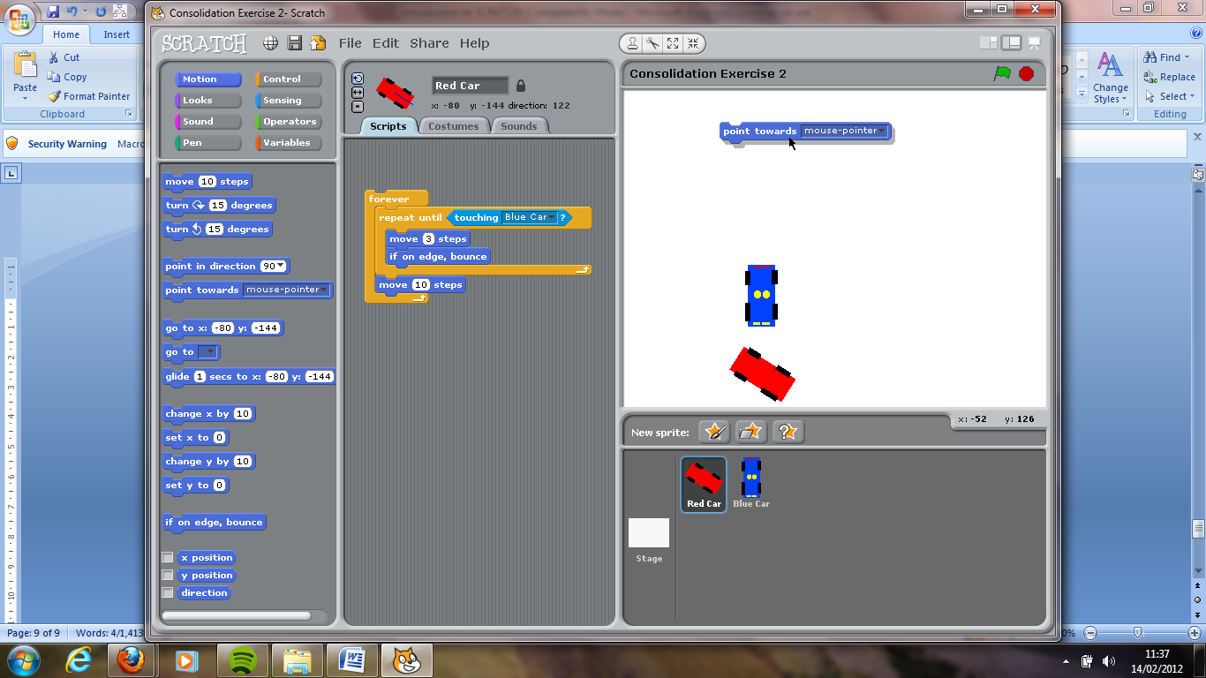

* Add the above script block in here!

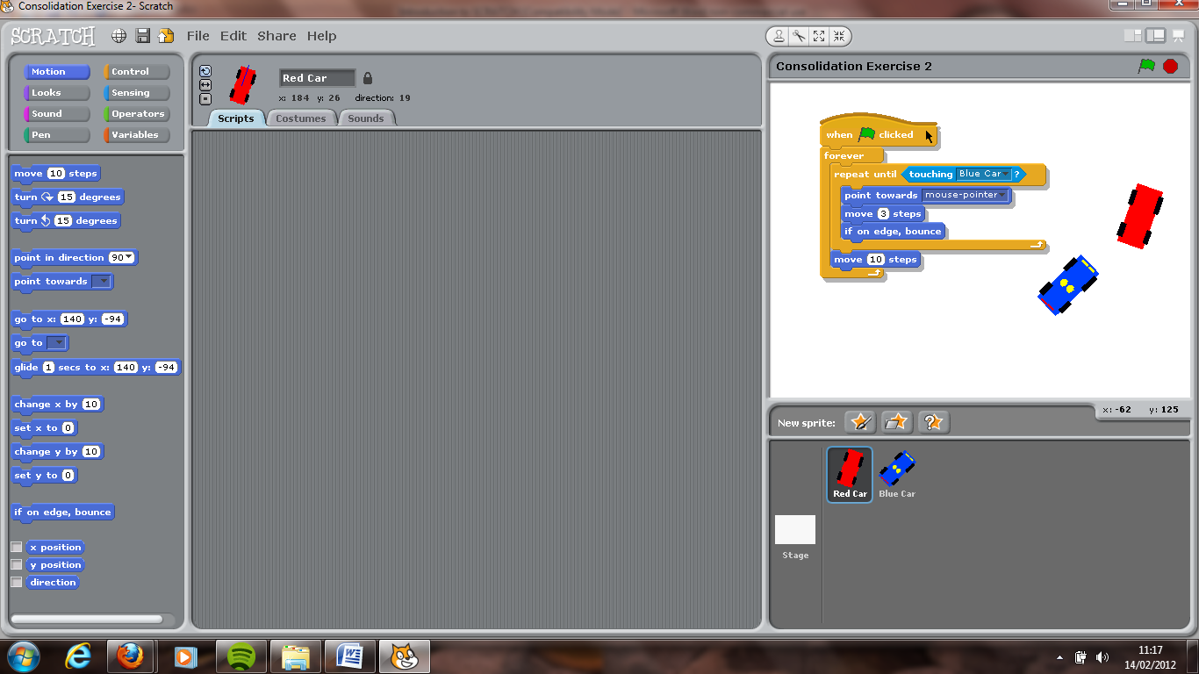

* Now run the program by clicking on the GREEN flag at the top of your screen.

I think this is really fun!!

(…& I could spend all day playing this)

* Save this as *Control Sprite Movement with Mouse*.

Costumes

Each sprite can have many costumes. That is, many appearances.

* Open up a new Scratch Project.
* Remove the default cat sprite and *Choose a new Sprite from file*.

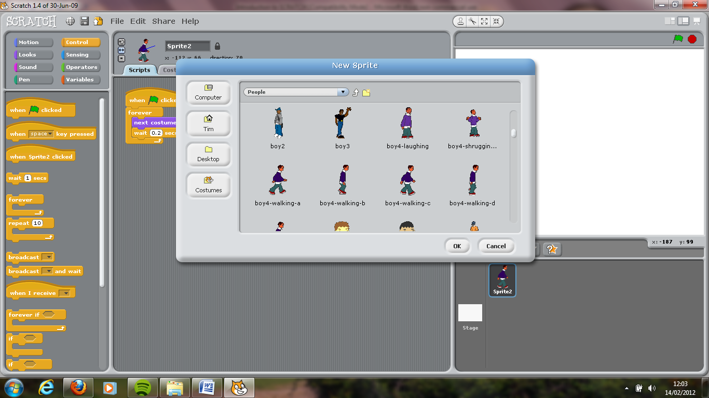

* Go to the ***People*** category folder. Look for the following sprite ***boy4****-****walking****-****a***.
* Select this sprite.
* Now select the **Costumes** tab at the top of the screen. Here we can give our sprite many costumes.

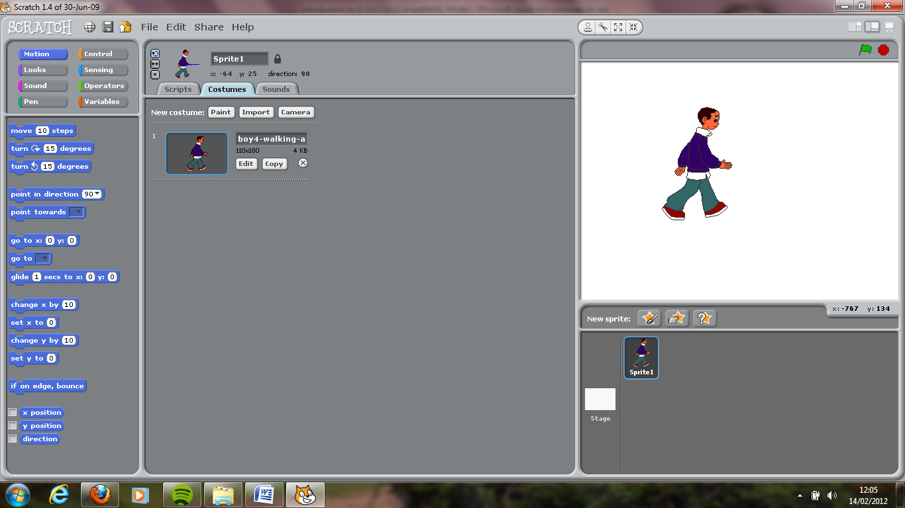

* Click on ‘*Import’* button.
* From the list of available sprites, import *boy4-walking-****b***.
* Repeat this again and import:
  + *Boy4-walking-****c***
  + *Boy4-walking-****d***
  + *Boy4-walking-****e***
* You should now have the following list of **costumes** for **Sprite 1**.

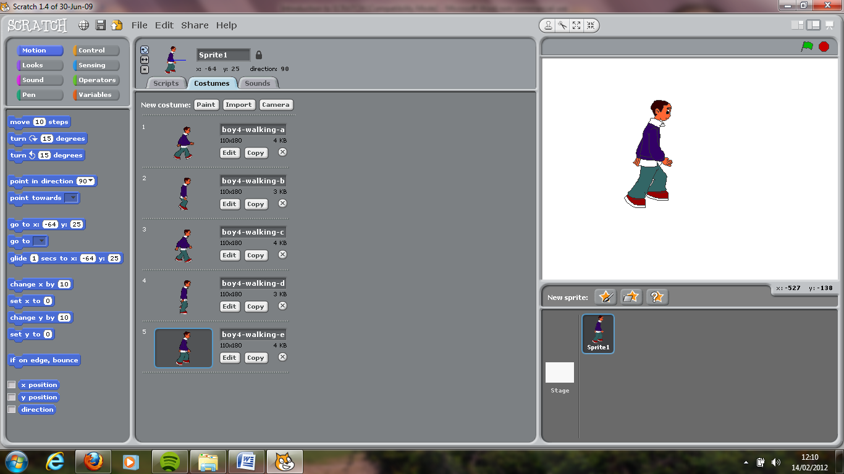

* You can change the name of your sprite if you want at the top of the screen.
* Now, go back to the *Scripts* tab by selecting **Scripts** at the top of the screen.
* From the ***Looks*** category, drag in a new script block called ***next costume***.

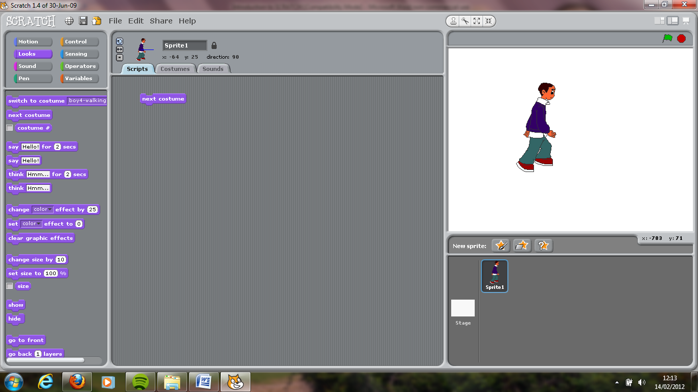

* Now, repeatedly double-click the little next costume block on your scripts panel and watch your sprite.
* Let’s re-introduce **Forever Looping** so we don’t have to keep double-clicking this. **See if you can do this without turning over to the next page**.
* I don’t know about yours, but when I do this my Sprite moves like Usain Bolt. He moves too fast!

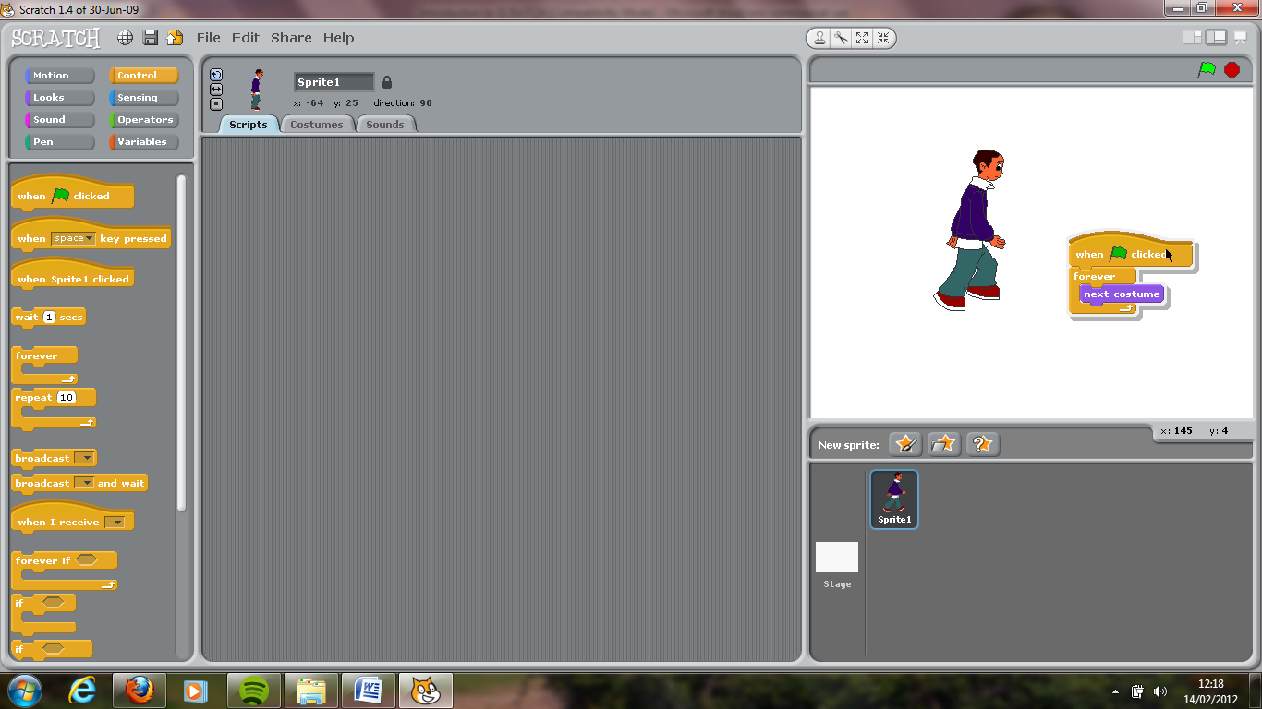

* Slooooooow him down by introducing a little wait block (found in ***Control*** category). Set wait time to 0.2 secs…which means that program will wait 0.2 seconds before changing to the next costume.
* It should look like this:

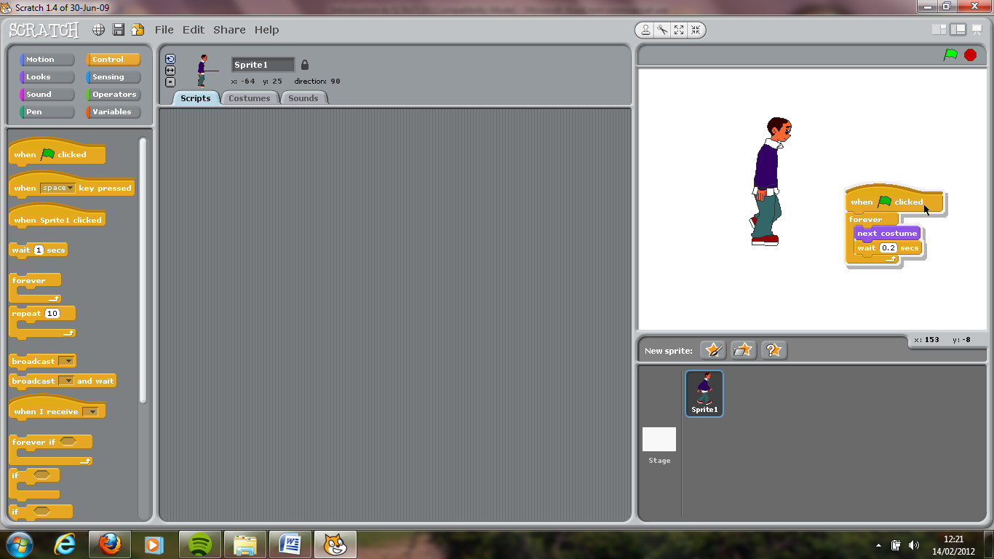

* Done? Ok…let’s improve our program by making our sprite follow our mouse-pointer around the screen. You did this before with the police car chase…remember? In case you’ve forgotten, here’s how:

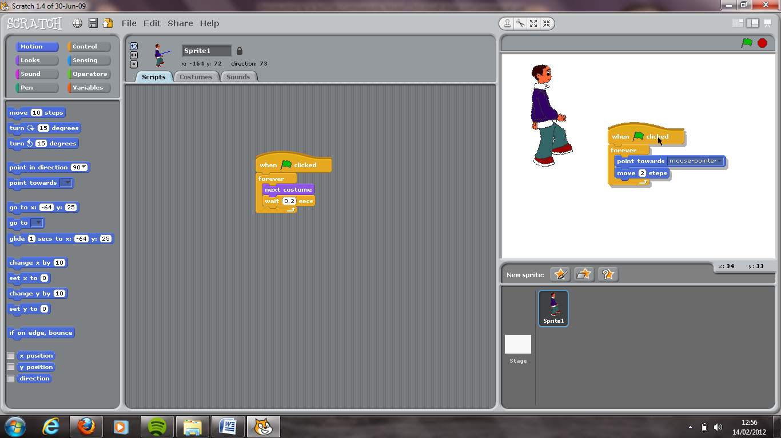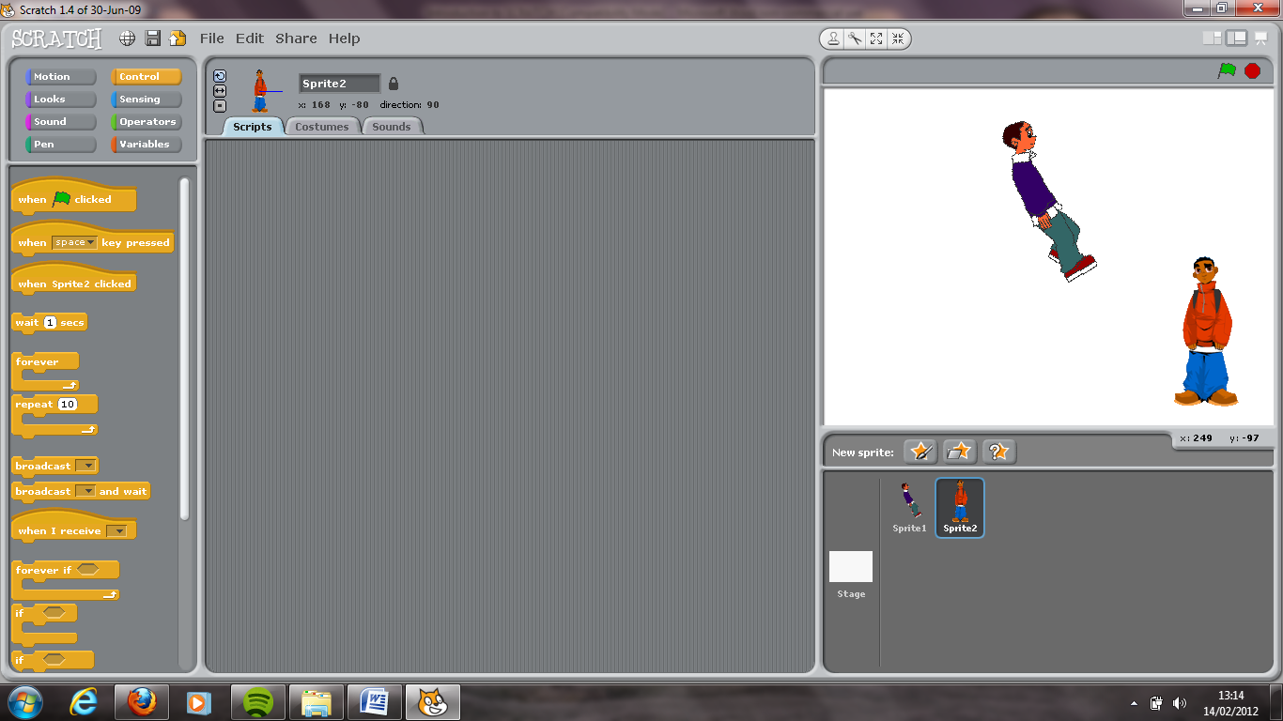

* Click on the green flag and test the program.
* Add another sprite. Choose ***boy1-standing*** from the sprite file.
* We now want to give *Sprite2* (boy1-standing) a second costume.
* Click on *Sprite 2* and then go to the *Costumes* tab.
* We want to copy costume one, so click *Copy*.

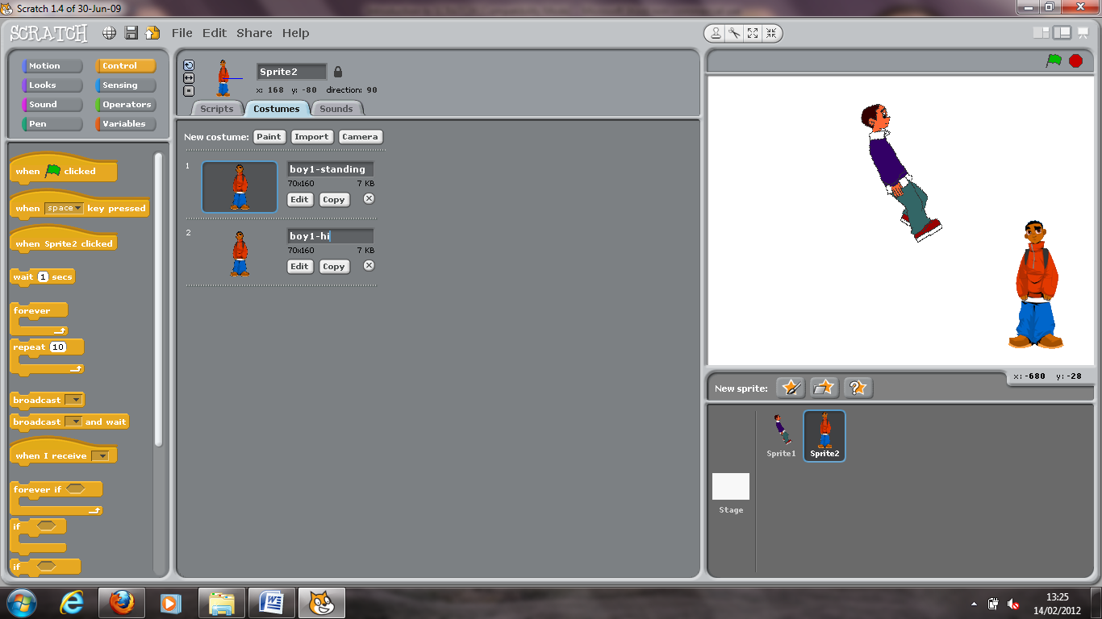

* Change the name of the second costume to *boy1-hi*.
* Now, click on edit
* In the paint editor, we can edit the costume in any way we want. All I want you to do is enter in the word *Hi!* You need to use the text tool to do this. See below:

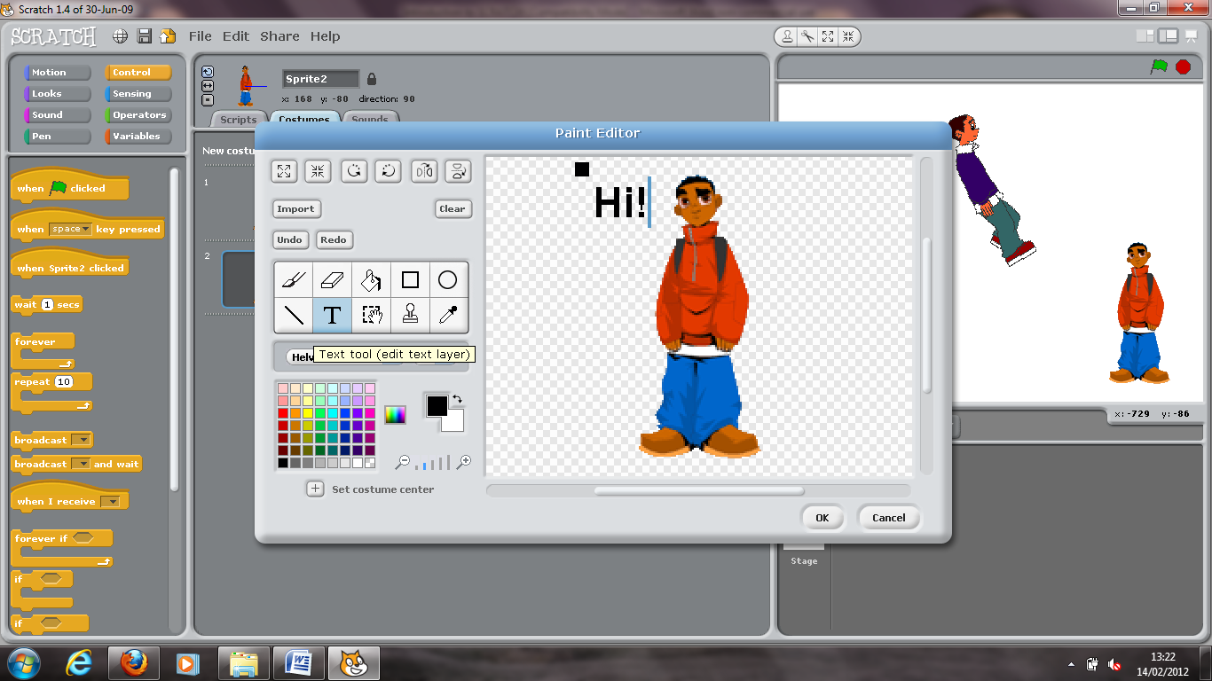

**T**ext tool

* Press OK.
* Open up the *Script* panel for *Sprite 2*.
* We want the following to happen:

When Green Flag is clicked

Switch to costume <***boy1-standing***>

***REPEAT UNTIL*** <touching Sprite 1 >

Switch to costume <***boy1-hi***>

* Scratch it and see what happens.
* Boy1 says hi …. But all the time! … I only want him to say hi whenever the two sprites meet!

Can you fix this?

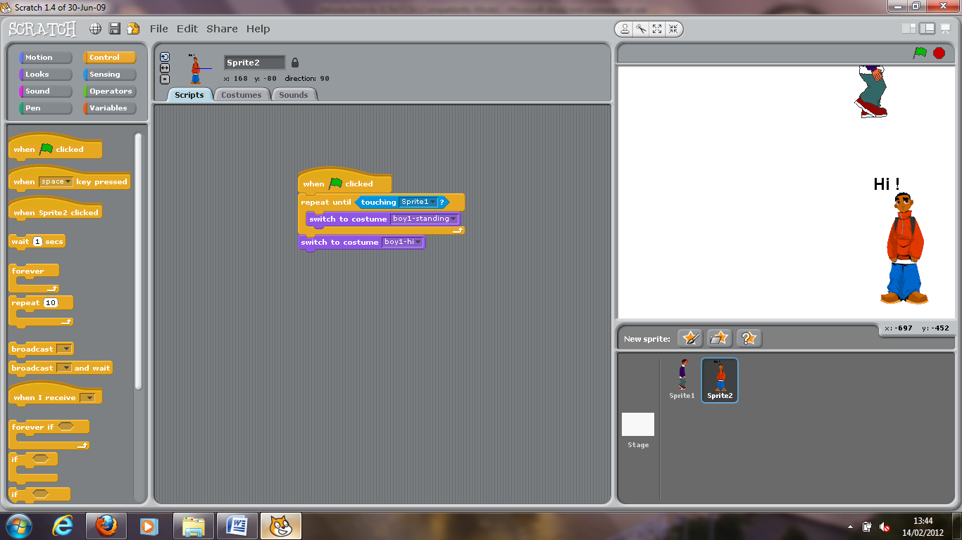

((Hint: Nested Loop!))

* Save this Scratch project as *Switching costumes*.

*(Teacher show video ‘Consolidation Exercise* ***3****’)*

* Before you commence this consolidation exercise, your teacher must show you two things:
  + **Shrink your sprite**.
  + **Import a new stage**.
* Create a new Scratch project called *Consolidation Exercise* ***3***.
* Re-create a new sprite based on ***boy4****-walking*. Make sure he has all the *WALKING* costumes:
  + Boy4-walking-**a**
  + Boy4-walking-**b**
  + Boy4-walking-**c**
  + Boy4-walking-**d**
  + Boy4-walking-**e**
* Boy4 must continually loop through these costumes during runtime, using a wait time of **0.2** seconds.
* Boy4 must be programmed to continually **follow** the mouse-pointer using **2** steps at a time.
* **Import** three other sprites *from file*. These will be car sprites (found in ***Transportation***folder). Select the following:
  + Car-**blue**
  + Car-**bug**
  + Car-**cow**
* Each of the vehicles (blue, bug and cow) must be programmed to drive across the road **forever** going back and forward.
  + Car-**blue** should travel **fastest** (move 3 steps)
  + Car-**bug** should travel slightly slower (move 2.5 steps)
  + Car-**cow** should travel **slowest** (move 1.5 steps)
* Boy4 should aim to walk across the road without being hit by any of the moving vehicles. If our sprite is knocked down, he shall say ‘***Owww*! Watch it!**’ for **1.5** seconds.

Save Scratch project as **Consolidation Exercise 3**

**Consolidation Exercise 3**

***Optional Extension*** (try this if you can!)

Scratch has some sounds (‘car passing’) stored in the *Sounds* library (beside the *Costumes* tab) and these can be imported and played as a loop during runtime.

Broadcasts

Broadcasting takes you to another level. It allows so much more flexibility and user control in a program.

* Browse for the Scratch project you created earlier called *Control Sprite Movement with Mouse*

This is what happens so far:



The getaway car follows your mouse

The police chases the getaway car

If the police car touches the getaway car, it yells "*Gotcha! ...Hold'em Up*!"

In response, the getaway car will sprint (move) 10 steps away!

Let's make life a little more difficult for the getaway car.

If the police car touches the getaway car ... an extra police car will now appear to help with the chase.

This extra police car will only be introduced **when told to do so**. This is what we mean by **broadcasting!**

* You should have the project file *Control Sprite Movement with Mouse* already open. Go to Save As and save it as *Extended Police Chase*.
* Right-click on your police car sprite and select *duplicate*. You should now have two police car sprites!

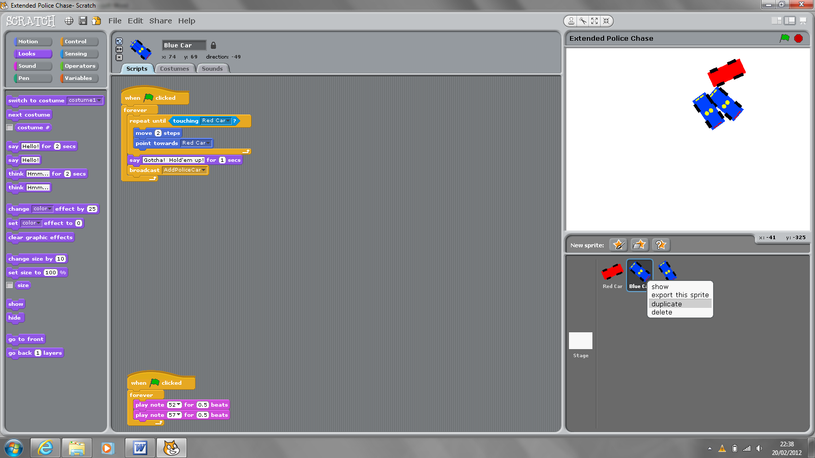

* Rename the second police car sprite ‘*Extra Police Car’*.
* The duplicated sprite (Extra Police Car) will also have the same script blocks as the original police car.
* Now, click on the original police car (Blue Car) and under the script category called **Control**, pick out the ***Broadcast*** script block.

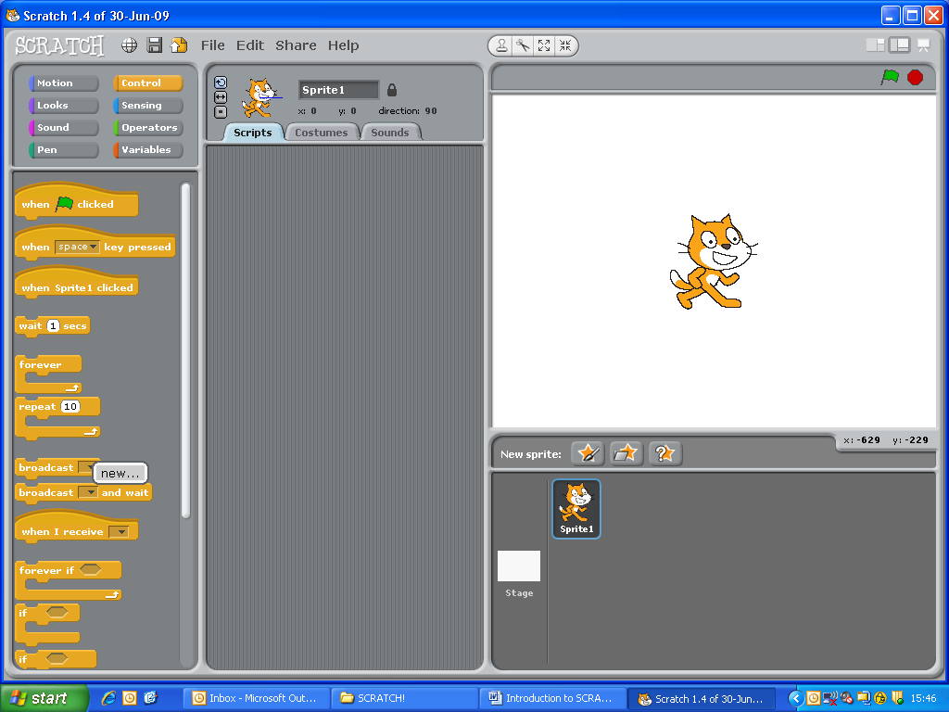

* Select *New…* and type in ***Add Police Car***. (You can add spaces if you want)

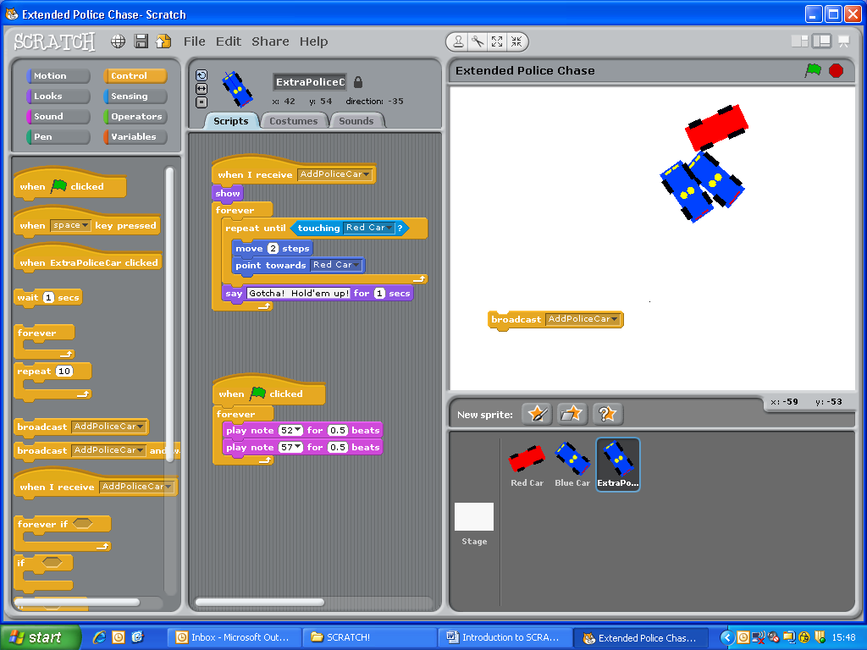

Very simple! This script block just broadcasts the message ‘Add Police Car’!

* WHERE do we place it? Well… we want this message to be broadcast when the getaway car speeds off after being ‘touched’ (caught). So it will go in here…

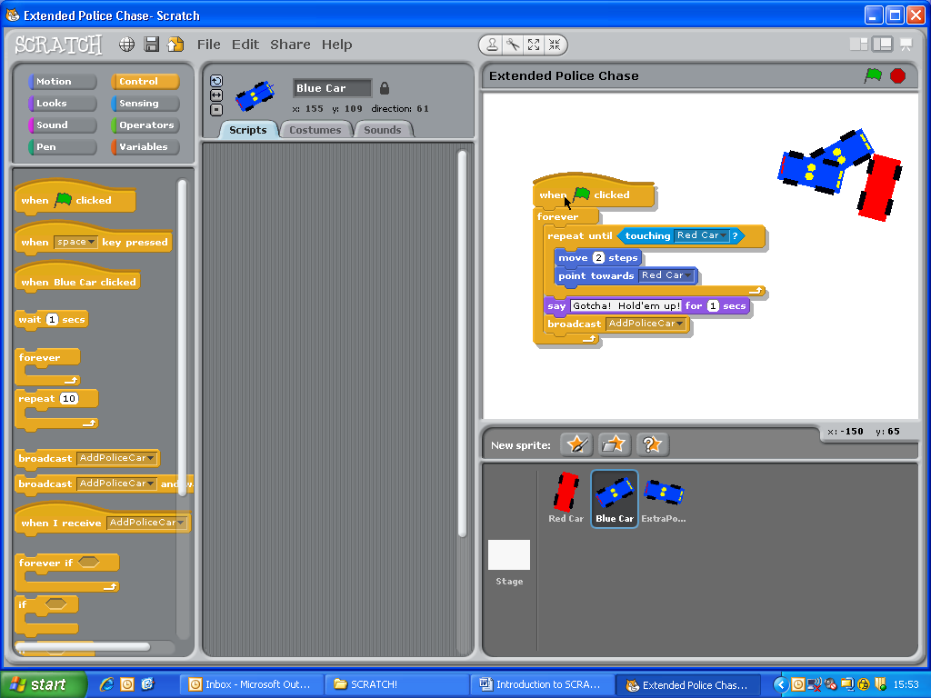

* Click on your new sprite *Extra Police Car*. We need to add some new blocks here.
* We only want the *Extra Police Car* to **SHOW** when the message *Add Police Car* has been **BROADCASTED**. The entire script block looks like this:

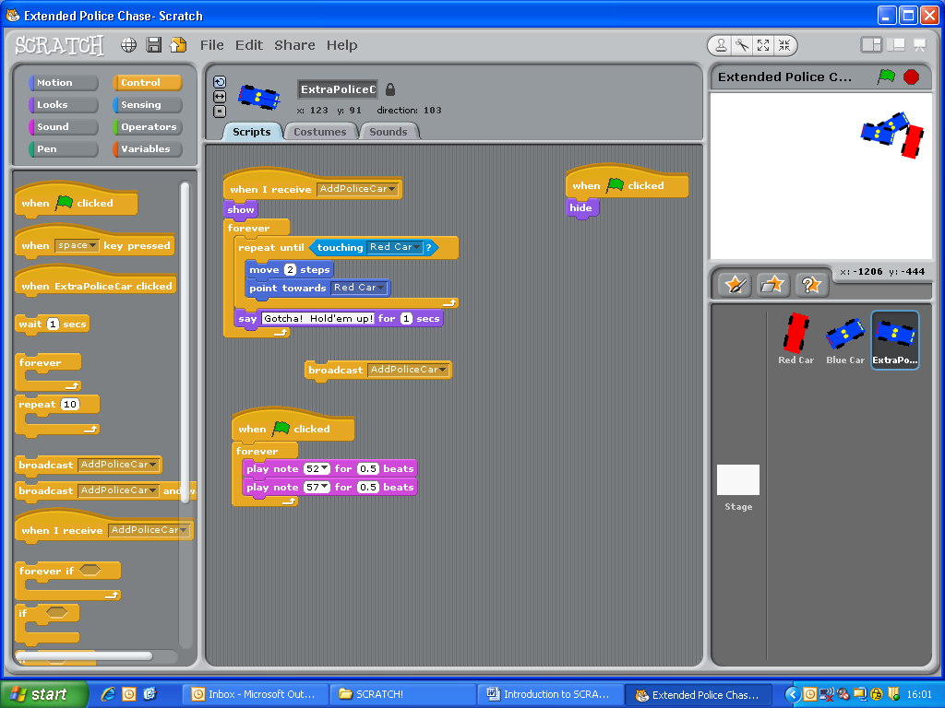

Look for the **When I receive** hat-block in the ***Control*** category.

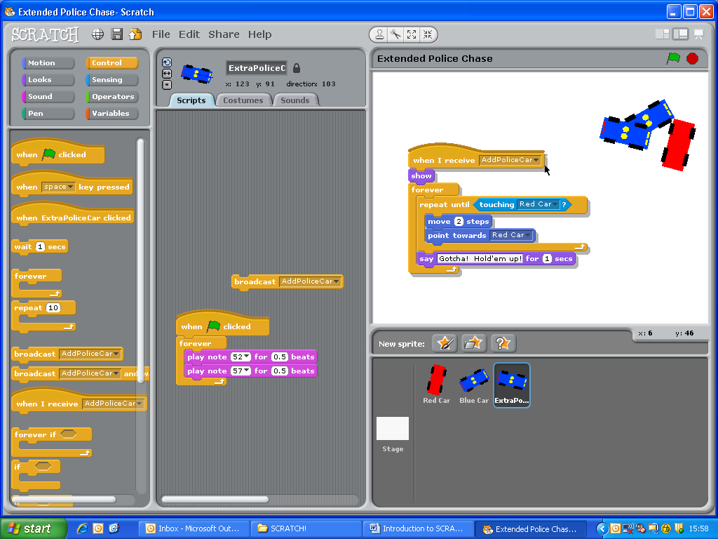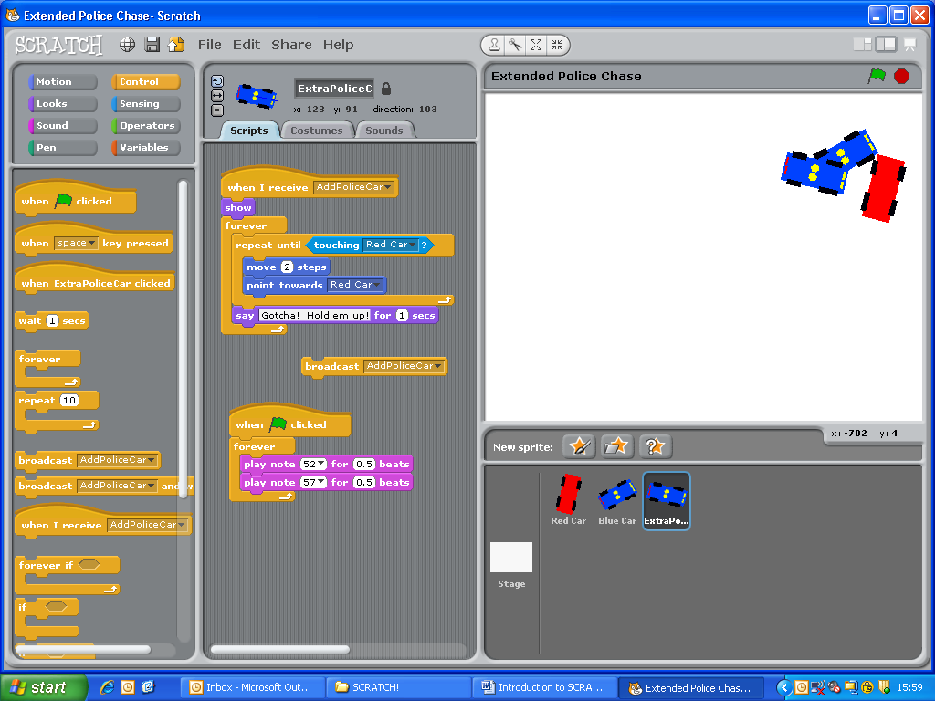

Look for the **SHOW** block in the ***Looks*** category.

* If you ran the program now, the extra police car will be visible from the start. This isn’t what we want! We want it to be invisible until it is called upon (receives ‘*Add Police Car*’ broadcast) Therefore add the following scripts to the *Extra Police Car*.

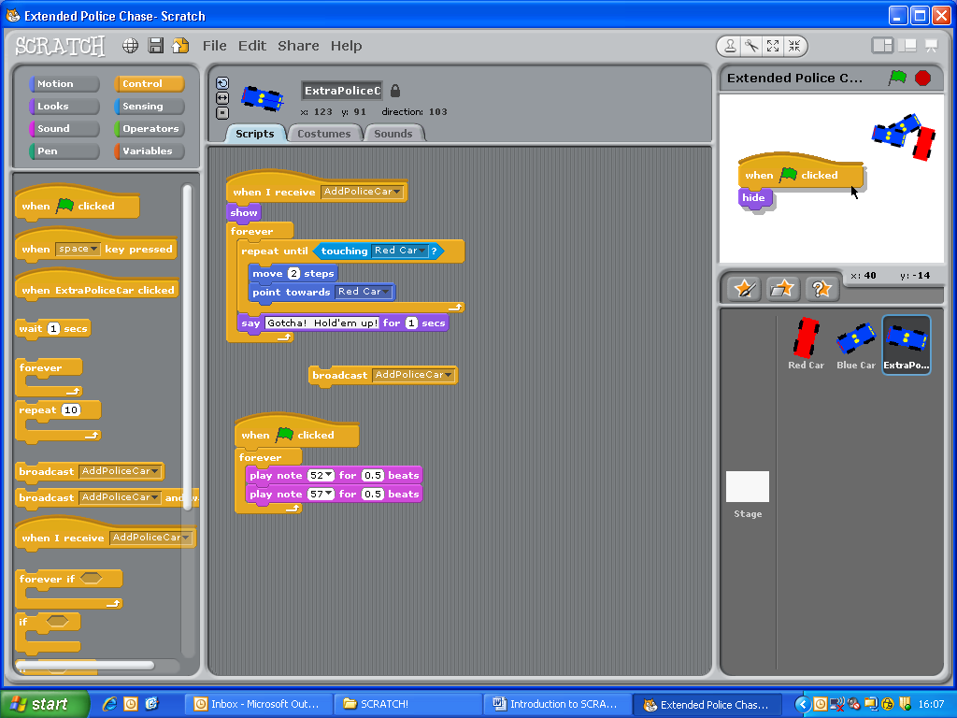

* Last step! Before you test the program, ensure that you place the sprites well apart. This is done by click and drag. Here’s mine:

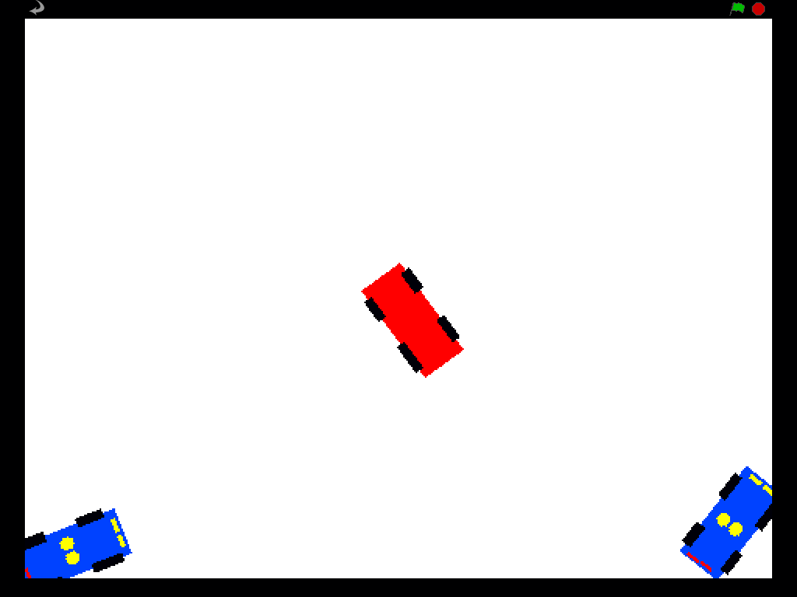

* Click the start **Flag** and enjoy! (Save as **Mini Chase**)

*(Teacher show video ‘Consolidation Exercise* ***4****’)*

* Improve the Scratch project entitled ‘*Extended Police Chase*’ by having **3** police cars chase the getaway car.
* At the start, there must be 1 police car. If this touches the getaway car, police car 2 joins in. If **only** police car 2 touches the getaway car, police car 3 joins in.
* The speeds of the 3 police cars must be different. Here are the settings:
  + Police Car **1**: moves **2** steps
  + Police Car **2**: moves **1** step
  + Police Car **3**: moves **0.5** step.
* All sprites must start off from different locations on the stage. (You can use a ‘***go to***’ block to help you here. Look under the ***Motion*** category)

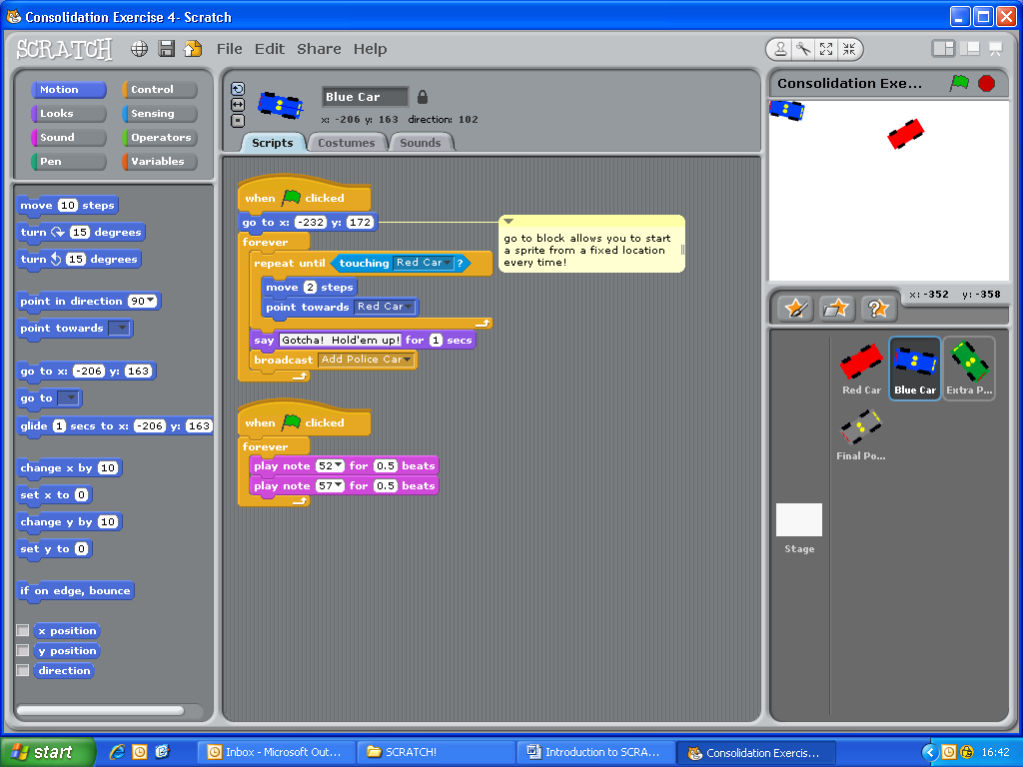

* Save as ***Consolidation Exercise 4***.

**Consolidation Exercise 4**

Variables and Operators part 1

Variables are a way in programming to store data. What can this data be?

* A number
* A letter or words

Think of a variable as a bucket, that you can put information in. When you want you can look in the bucket and see what is it and if you want, you can empty it and put something new in it.

Variables are found in the variable submenu

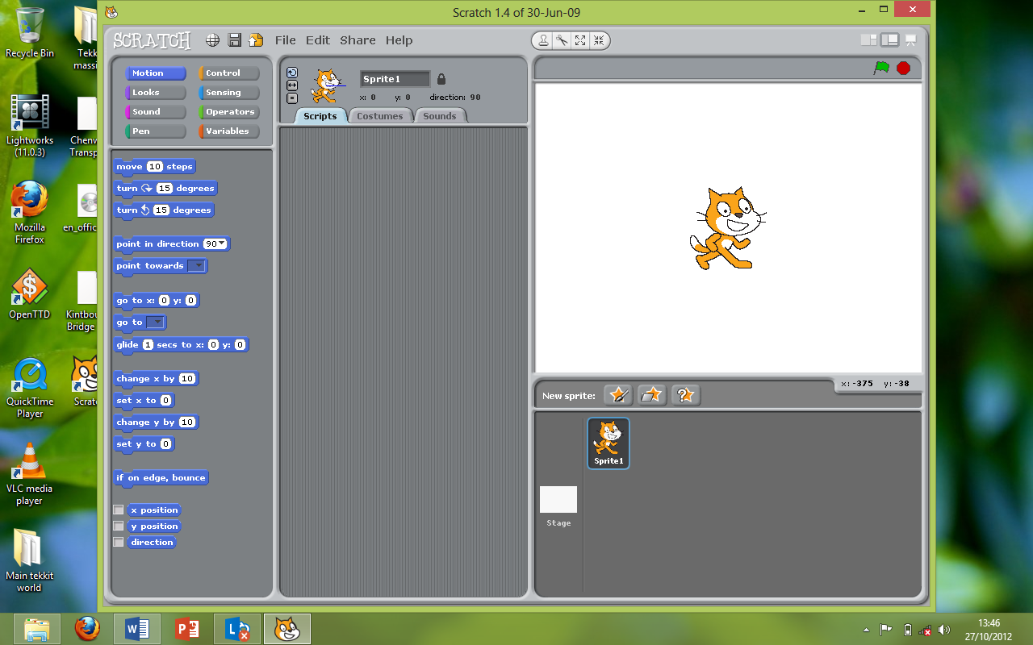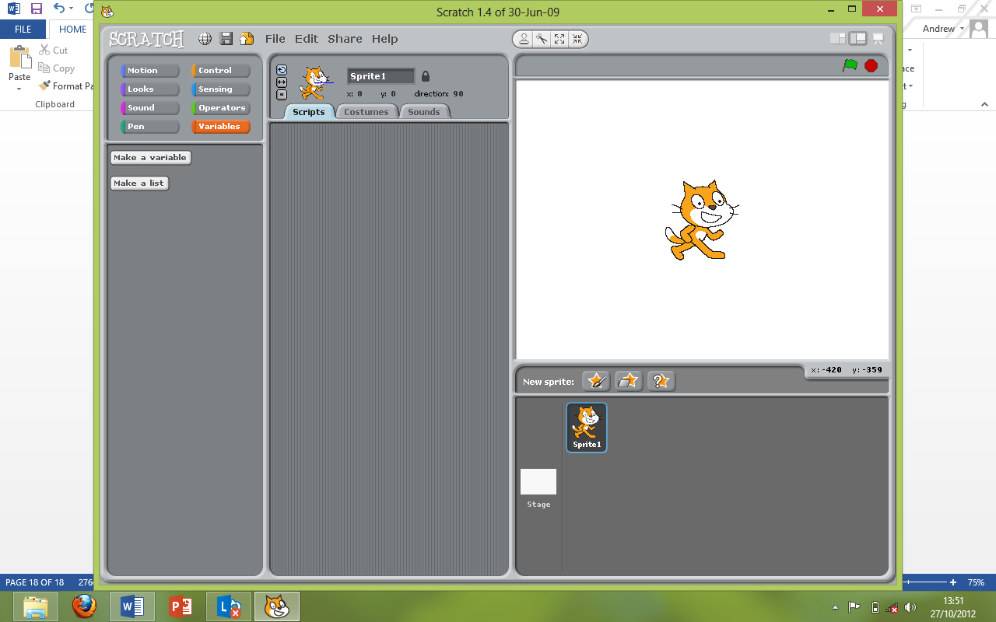

* When you open the variables menu, there is just 2 options, make a variable and make a list
* We will be focusing on making and using variables and leave lists till later on.
* So, open up ***Consolidation Exercise 4*** and click “Make a variable”. Then enter a sensible name for your variable, let’s call this “***Count***” and make sure “For all sprites” is ticked.

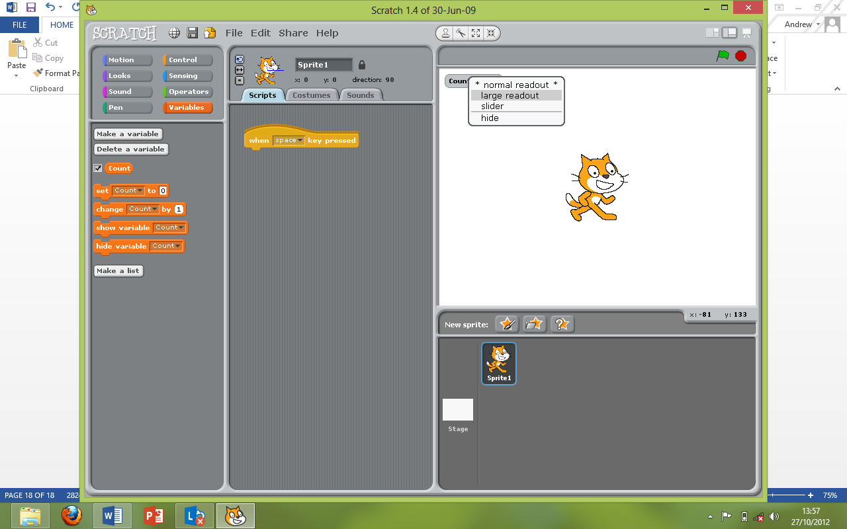

* Ok, now we have a variable to store some data, let’s use it to do some maths.
* First off, right click on your “***Count***” variable at the top left of the stage and click “Large Readout”
* This allows us to see it a lot better (***Tip*** – Changing it to slider allows you to manually change the number in a variable on the fly)
* So, what would I need a variable for I hear you ask? A score counter of course!
* We are going to add a score counter to your game. We want the score to go up every time the car gets caught by the first police car
* This is the variable visible tick-box. Untick it to hide the variable readout in games
* Allows you to empty the variable (bucket) and force a new number in it
* Allows you to do some maths, like adding 1 to what is already in the variable (bucket) or minus 1 etc.…
* Same as the variable visible tick box except these can be used in your programs!

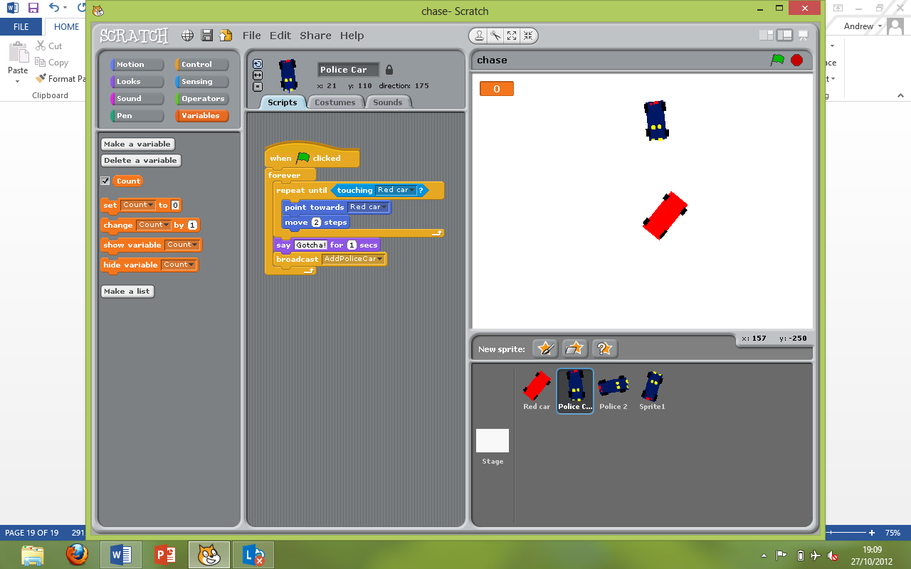

So, now you know what all the variable stuff does, lets get into some examples!

* I want the score counter to add 1 point on every time ***police car 1*** touches the ***red car.***
* To do this we will need to change the variable count by +1, or just by 1.

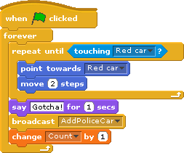

Remember, it does not matter the names you give to variables or sprites (try and make them sensible though so if you show your program to someone else, they can understand it).

* Let’s once again improve on the car chase game, open ***Consolidation Exercise 4***
* You must create a variable called score and
  + Make sure it is visible in the stage
  + Make sure it is in large readout mode
* Add points on depending on which police car catches up with the red car
  + Police car 1 (the fastest) – 1 point
  + Police car 2 (middle speed) – 2 points
  + Police car 3 (slow) – 3 point
* Tip, why not also add a wait 1 second right at the end of each of the police car scripts so you can’t get caught over and over again in a loop

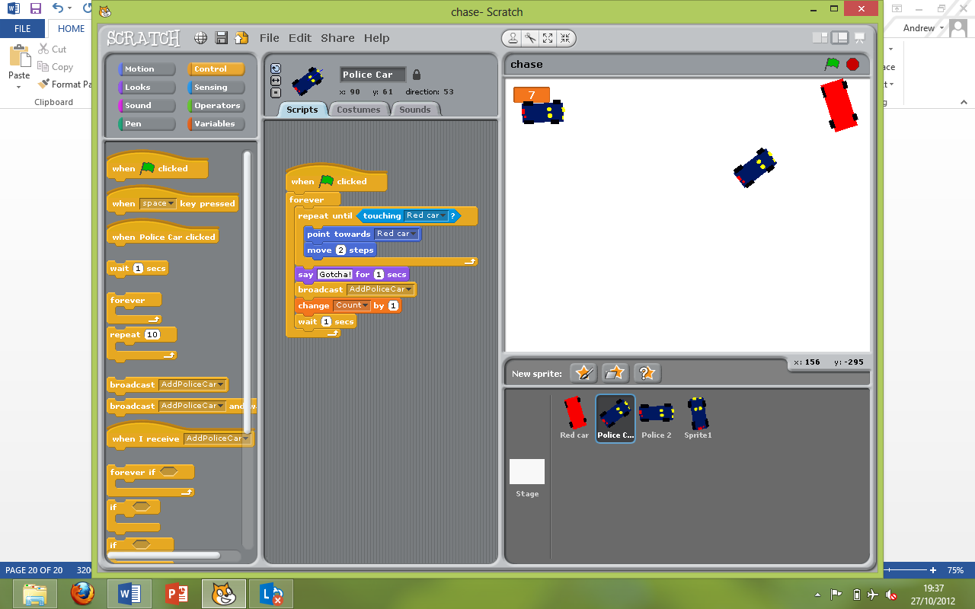

* Find the wait block here
* Add it in around here

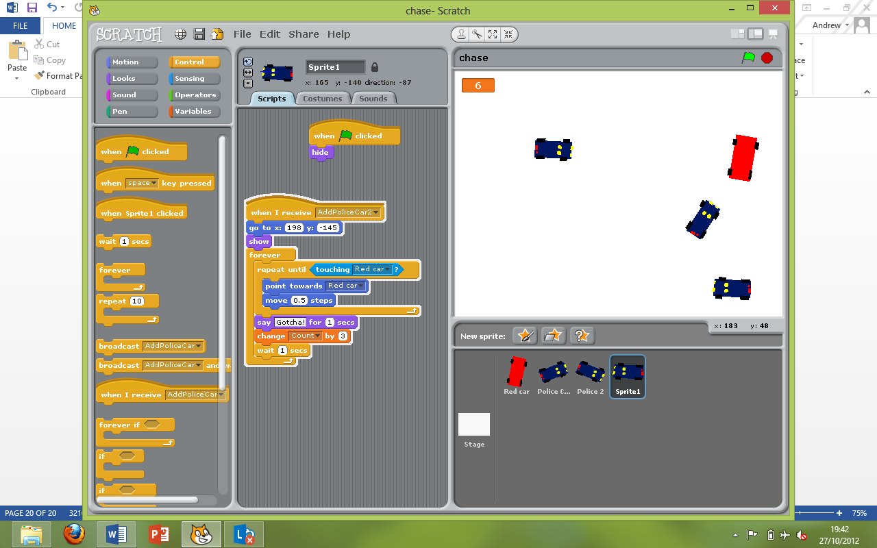

* Remember, we are adding points on, not setting them so after I hit each of the 3 police cars once my score should read
* Save as ***Consolidation Exercise 5***.

**Consolidation Exercise 5**

Variables and Operators part 2

Now for the fun advanced stuff, you already know how to store your number in your bucket, now you need to learn how to do stuff with it other than just show it to the player of your game.

To do stuff with it we will use operators. Operators allow you to do mathematical stuff with numbers (add, subtract, multiple, divide), compare 2 numbers (are these 2 numbers the same? Is number A bigger than number B? and so on…, combine words together or count how many letters are in a word and much more! The possibilities are endless and we will only go into what a few of these things do, the rest will be up to you to try out and figure out what they do!

* So, lets get started, we are going to make a basic calculator in scratch. First we need to figure out a way to get what you want your numbers to be into scratch. To do this there is a few ways but we will be using the “ask” method.
* This involves scratch actively asking you which numbers you want to add up.
* So first, create 3 variables, “Number1”, “Number2” and “Answer”. Remember it is important to name your variables a meaningful name! Also, don’t forget to change the “Answer” variable to ***Large Readout*** mode.
* Create a sprite to ask for the numbers (you could do it in the stage but that is a little more complicated….)

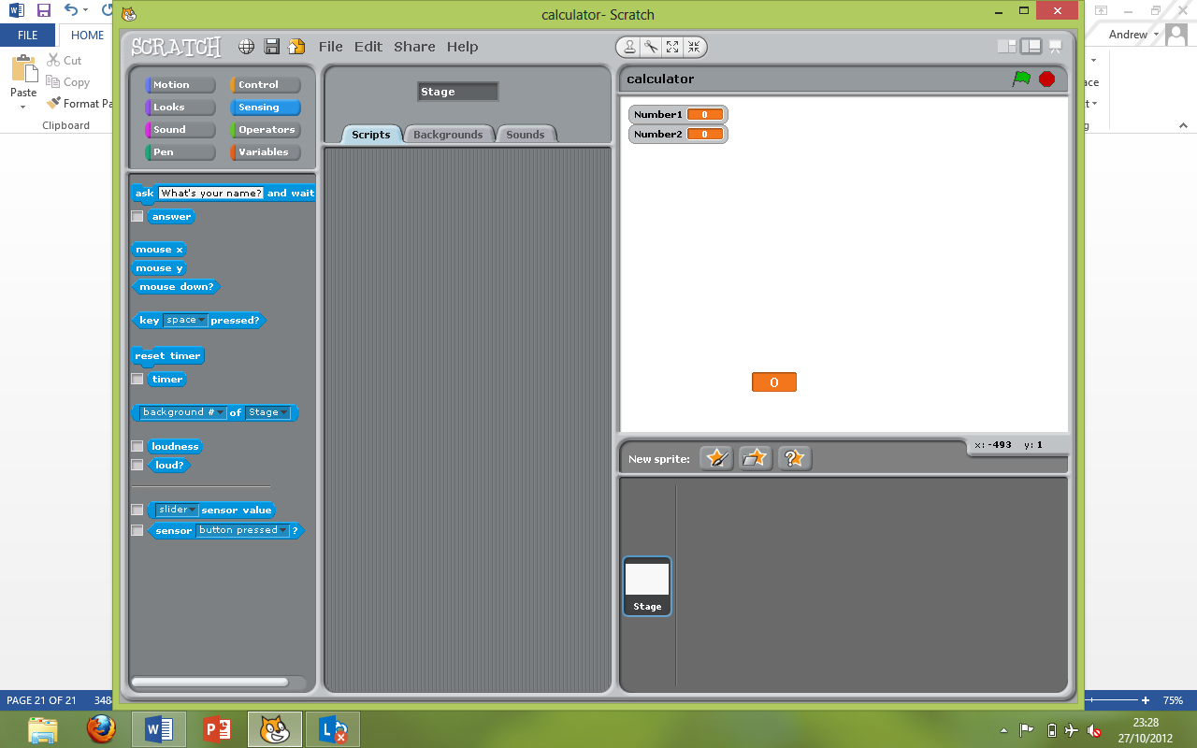

* We will need to get the info off the user so we will use the ask block found in the sensing section
* The ask block works by

asking the user to reply to whatever you

set the question to, the example is “What’s your name” which you will need to change.

* Any rounded edge block like this block is a reporter, it reports the value of something, in this case it holds the answer to the above question, it is a specialised variable that comes built-in. There are many of these reporters in scratch for you to use!

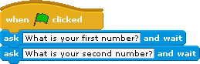

* So, now we know how to make a question, we need to put it into a program.
* The program to the right Is a start, but we need to save the answer to those questions because as soon as we ask the second question, the specialised variable “answer” gets rewritten with the 2nd number!

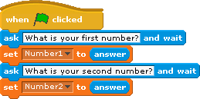

* So, let’s put the 2 numbers we get into their variables like the example shown to the left

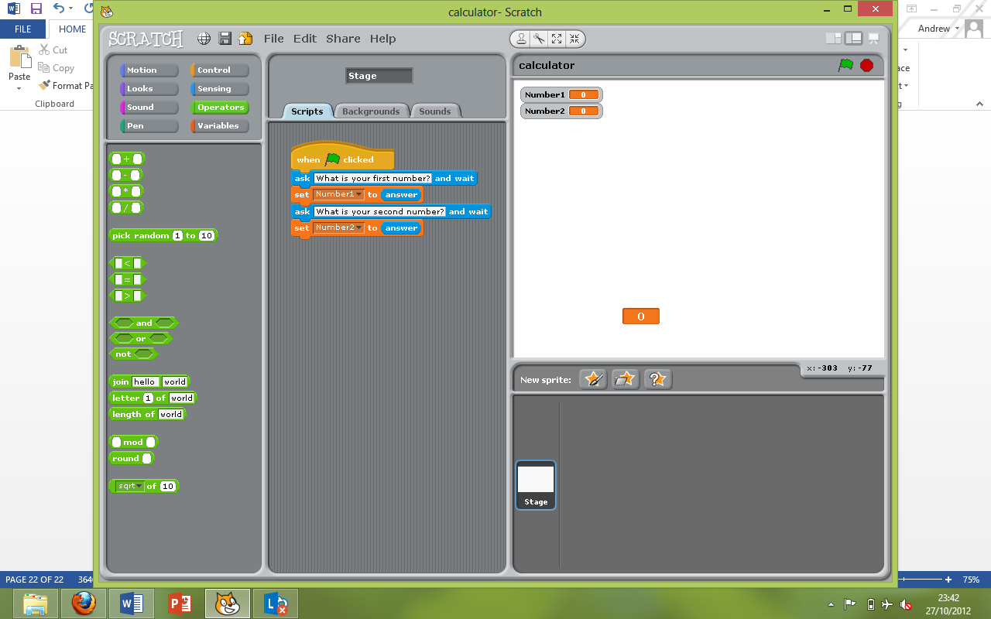

* Now for the operators, these are green and found here.
* We need to add the 2 variables together, now it’s your turn, can you figure out using 1 of the 4 blocks to the left, how to add the variables together? Ask your teacher if you get stuck with this.
* So now you have a basic calculator from the exercise above, its time to make a more advanced one. Your calculator should be able to add and subtract numbers with a button to switch between the modes

**Consolidation Exercise 6**

* Tip – Use 1 sprite for the button but swap its costume when it is clicked so the user knows what will happen if they press the button again.

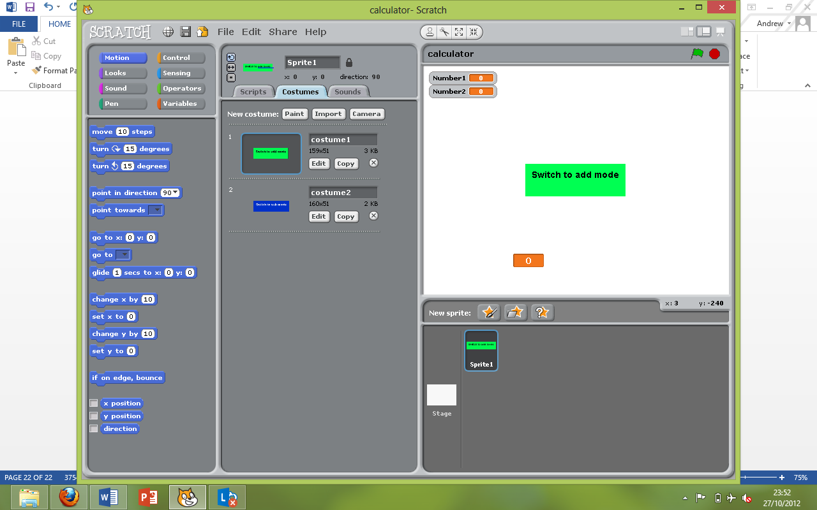

* This exercise is a little tricky, make sure to ask your teacher if you don’t get it!!
* Save this as ***Consolidation Exercise 6***

**Bonus Exercise 1 – Pen tools**

* The pen tools in scratch allow you to draw on the stage and easily clear it when you are finished

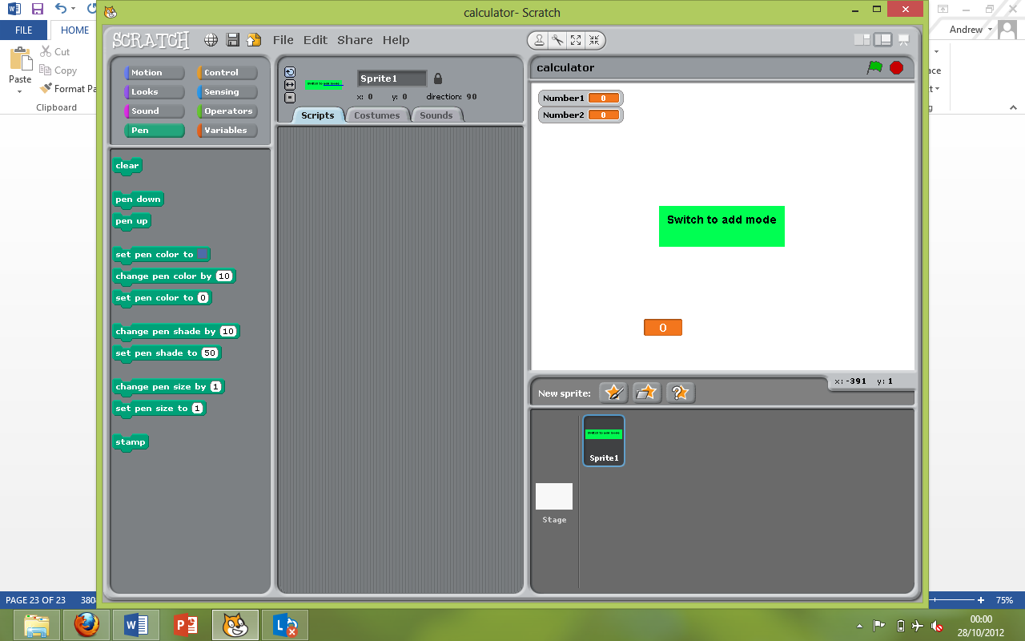

* The tools are very self-explanatory.
  + Clear – This clears the stage of all previous drawings
  + Pen down and pen up allow you to start drawing and stop drawing
  + Pen colour can be set as a number or a specific colour
  + Also the pen size can be changed to be thicker or thinner
  + The last item, stamp…. You can work that out for yourself, have a play around with it!
* Create a game in which using the arrow keys, you can move a sprite of your choice around the screen.
* Then, when the “m” button is pushed, the pen is put down
* Then, when the “k” button is pushed, the pen is lifted again
* And finally, when the “c” button is pushed, the whole stage is cleared
* Get drawing!

**Bonus Consolidation Exercise 1**

Then pen tool can be used to do piles of things, for example, here is a few ideas for some stuff you can try if you have spare time

* + Automatic drawing of circles, which get bigger and bigger
  + Get the colour to change depending on the sprites 6 coordinate

**Bonus Exercise 2 – Logic 1**

Logic is hugely important in programs, a computer must make decision on what to do when. Sounds simple, write a program and get the computer to do the decision making for you? Well, it actually is quite simple and in scratch it is all in plain English.

The most basic logic statement is an “if” statement. What an “if” statement does is when it is run, it checks **if** a certain thing is true. E.g.

* If your test mark = 100 then you got full marks
* In plain scratch : if “score” (a variable) = 100 then tell you that you got full marks. It looks like this in scratch

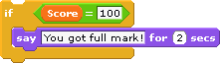

* With this script above it will only tell you “You got full marks!” if you get 100 marks
* You can also do less than and more than instead of using equals if you want. (Less than < ) (More than > )
* We can also go a little more advanced with an “if else” statement, this is exactly like an “if” statement but it has an “else” part to it. If your test score does not = 100 then it will say “You didn’t get full marks :(

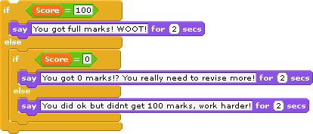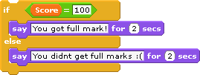

* You can also nest these if statements inside each other to check multiple things. Check out the example script ->
* Create a menu system, the user can enter a number from 1-4, if they enter anything else that isn’t 1, 2, 3 or 4, it must say “ERROR”
* You can get it to say whatever you want for the 1-4 options
* You will need to ask for a number and if you want put it in a variable, but this is not required (remember built in “answer variable”)

**Bonus Consolidation Exercise 2**

* Remember – This stuff is complicated and don’t be scared to ask for help!!!